General Notes

This very simple database records attendances for each class and week no. It assumes that each class runs a fixed number of times (10 in this example) so may not be that flexible.

The object general properties (check Access Help if you don’t know what these are) of each table, query and form have been filled in to provide documentation on the purpose of each object. Read these for further information.

The database was created following ideas from helping a Placement and a FY Project student, both creating school Attendance Register databases. It demonstrates a method of recording and analysing attendances.

It does not allow for Class Year or any other such refinements that may be needed in a full system.

Contents

Tables and Relationships

Forms
ChooseClass
AttendanceRegister
ChoosePupil

Links to the queries
AttendanceRegister
PupilAttendance
PupilAttendanceAll
PupilAttendanceAll_Crosstab

Saving query results

More information on using a Crosstab query

Tables and Relationships

Attendances are recorded within the Register table.

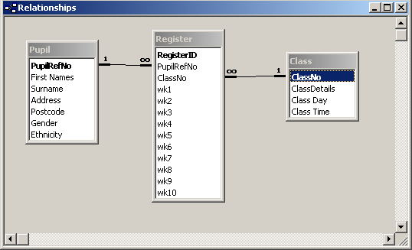

Class Day probably better as a single digit 1-7, linked to a separate ClassDay lookup table.

There are just three data tables in this example.

More tables would be needed in a full-blown system.

See section 3.6 of the ‘Getting Started’ VBA Trainer for how to use VBA code with combo boxes such as the Ethnicity combo box.

Forms
This is a simple list of numbers 1 – 10. It would be better in a table with week start date as well.

ChooseClass
An unbound form.

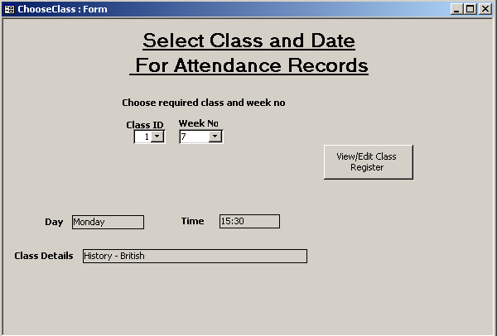
Based on Class table, ordered by Class Details.
AfterUpdate event puts selected ClassNo in the ClassNo table.
Opens AttendanceRegister form.
These textboxes have values put in when a class is chosen from the Class combo box (see AfterUpdate event).

AttendanceRegister

A tabular form, based on the AttendanceRegister query, thus ultimately bound to the Attendance table.

This query shows all values on the wk1-10 boxes for all Pupils registered for the class selected on the ChooseClass form. It uses all three tables with normal Inner Joins (the default Access join).

The form AllowAdditions property has been set to No to remove the new record row at the end of the data.

The form shows all attendances at once, with the percentage attendance so far.

Pupil and Class details shown Locked, and with other properties changed so they are obviously not for data entry.

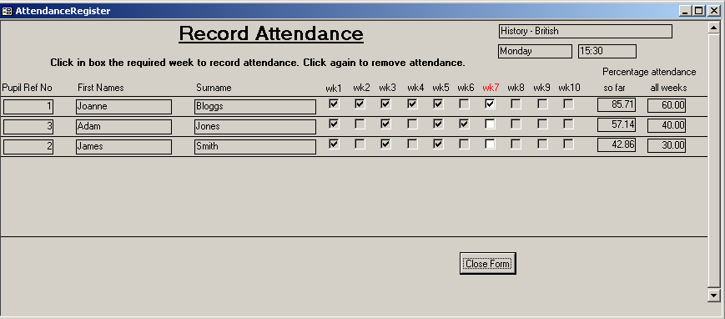
The wk1-10 boxes are disabled initially.
In the Form_Load event the column for the week no specified on the ChooseClass form is enabled and the column heading font is shown as red. This shows the user which column is to be used for the current register and avoids inadvertent changes to attendance for other weeks.

User clicks on the wk1-10 box to record/remove attendance.

The two percentage values are calculated in unbound textboxes.
- A checkbox can contain one of two numeric values:
  - 0 = False/No (no tick)
  - -1 = True/Yes (tick)
- The formulae in these textboxes add up the values in the check boxes for the row.
- As the sum will either be zero (if there are no ticks in the row) or a negative number (if there is at least one tick in the row) the ABS function is used to remove the negative sign and get the absolute value of the total attendances (e.g. 3 ticks adds up to -3, and ABS(-3) = 3).
- The percentage so far uses the week number entered in the ChooseClass form; this is assumed to be the current week.
- The percentage for all weeks is out of 10 possible attendances.

See the AttendanceRegister2 example database for how to check if there are any pupils registered on the chosen class. If there are no Pupils for the Class, the detail section of the form is blank.
ChoosePupil

Very simple form, to select a pupil and see the attendance record (with a percentage attendance for each class) across classes as supplied by the PupilAttendance query.

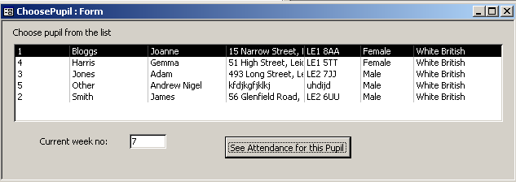
List box based on Pupil table, sorted by name.

Current week no is used to calculate percentage attendance so far.

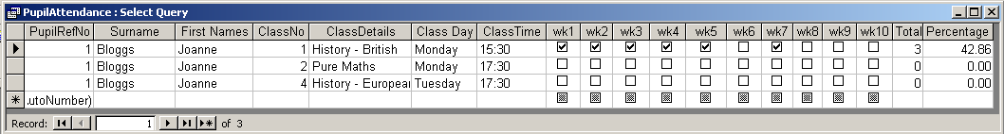

The PupilAttendance query is an inner join query selecting values from all three tables.

The Total and Percentage columns are calculated fields:
- The Total uses the ABS function to add up the ticked check boxes.
- The Percentage is calculated by using Total and the week number entered on the ChoosePupil form.

See section 3.6 of the ‘Getting Started’ VBA Trainer for more information on how to code for list boxes on forms.

See the AttendanceRegister2 example database for how to allow the user to select all pupils or just one pupil.

PupilAttendanceAll_Crosstab

This is currently a stand-alone query, and shows the attendances of all Pupils in the database across the modules for which they are registered.

Pupils who are not registered for any module will not show; you will need to use an Outer Join query for that.
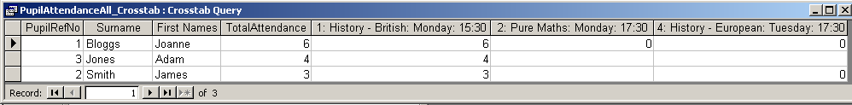

The Crosstab query is based on the PupilAttendanceAll query, which…:
- …selects pupil and class details
- …concatenates the class details into one field for the Crosstab column heading
- …has a calculated field using the ABS function to add up total attendances.
The sort order has been added afterwards.

Saving query results

Query dynasets can be saved to a spreadsheet if wanted. This can be done by simple copy-and-paste for users who know how to do this, or via VBA code with DoCmd.TransferSpreadsheet. This is very easy to use, and there is some discussion of it with an example in the ‘Getting Started’ VBA Trainer, section 7.3.5.

More information on using a Crosstab query

See the ‘Getting Started’ VBA Trainer, section 8.4.

End of notes.

