General Notes

This database records attendances separately for each class and date where a register was taken. It could thus prove a reasonably flexible method of recording attendances, as it allows for variable numbers of occurrences of classes, and for missed registers or cancelled classes. But it doesn’t cater for the situation where only the teacher turned up and it is wished to record that the students didn’t.

The object general properties (check Access Help if you don’t know what these are) of each table, query and form have been filled in to provide documentation on the purpose of each object. Read these for further information.

The database was created following ideas from helping a Placement and a FY Project student, both creating school Attendance Register databases. It demonstrates a method of recording and analysing attendances.

It does not allow for Class Year or any other such refinements that may be needed in a full system.

Contents

Tables and Relationships

Forms
ChooseClass
AttendanceRegister
ChoosePupil

How some of the other queries work
AttendanceRegister_Crosstab
PupilsForAllClasses - all Pupils

Links to other queries
AttendanceByDate
AttendanceRegister
AttendanceRegisterAllDates
ClassDates
PupilAttendance
PupilAttendanceAndPercent
PupilsByClass PupilsByClass (query used in two places)
PupilsForAllClasses
PupilsForAllClasses_Crosstab
TotalClassOccurrence

Saving query results

More information on using a Crosstab query

Can’t enter data in a form

Tables and Relationships

Attendance table only shows rows where an attendance has been recorded.
TickIfHere should always be Yes.

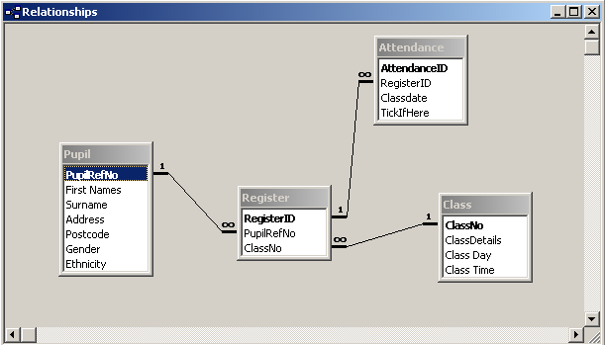

Class Day probably better as a single digit 1-7, linked to a separate ClassDay lookup table.

There are just four data tables in this example.

More tables would be needed in a full-blown system.

A fifth table ClassNo (not shown here) is used to store a ClassNo parameter for use in the PupilsByClass query, as that query is later used for a Crosstab query.

See section 3.6 of the ‘Getting Started’ VBA Trainer for how to use VBA code with combo boxes such as the Ethnicity combo box.

Forms
Based on Class table, ordered by Class Details.
AfterUpdate event puts selected ClassNo in the ClassNo table.

ChooseClass
An unbound form.

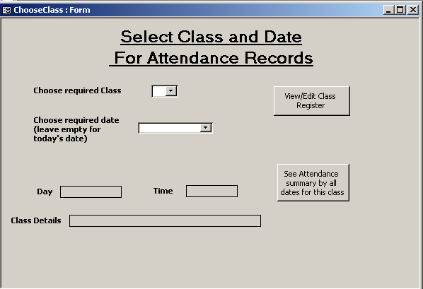
Based on ClassDates query, ordered in descending date order.
Code defaults to system date if this control is left blank.
Opens AttendanceRegister form.
Runs query AttendanceRegister_Crosstab

These textboxes have values put in when a class is chosen from the Class combo box (see AfterUpdate event).
AttendanceRegister

A tabular form, based on the AttendanceRegister query, thus ultimately bound to the Attendance table.

This is an Outer Join query to show attendances (if any) for all Pupils registered for the class selected on the ChooseClass form. The Outer Join is between the AttendanceByDate query (selects all attendances for the required date) and the PupilsByClass query (selects all pupils registered on the required class) with the join set to select all rows from the latter query.

The form AllowAdditions property has been set to No to remove the new record row at the end of the data.

Pupil and Class details shown Locked, and with other properties changed so they are obviously not for data entry.

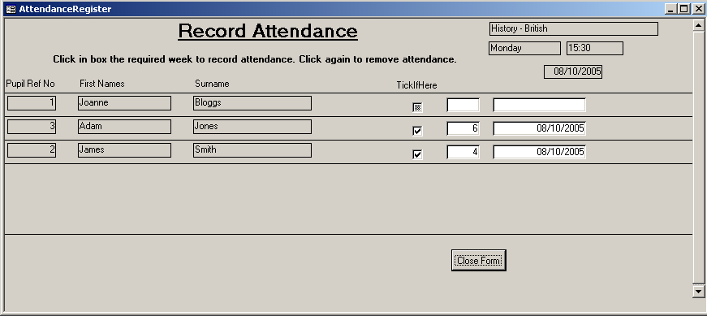
User clicks on the TickIfHere box to record/remove attendance.
RegisterID and ClassDate values, bound to the Register table. These fields are visible so that you can see what is going on, but they should be set to invisible for the final form, so that the user sees just the Pupil details, and the TickIfHere box.
- If an attendance is recorded, then Access calculates the RegisterID as this is an AutoNumber field. VBA code is used to put the ClassDate on the form.
  - The Attendance table record is saved automatically by Access when the user moves to the next record or closes the form.
    - The RegisterID and the ClassDate are both ultimately bound to the Register table, so these values will be written to that table.
- If an existing attendance is removed (i.e. the TickIfHere box is unticked) then the record is deleted from the Attendance table, by VBA code calling the wizard code created for a Delete command button (the button was then deleted, but Access does not delete the code so it can be used as a procedure).
  - In this way, the Attendance table only records actual attendances; there are no rows for non-attendances, so that aggregate and Crosstab queries can be used to count up attendances.

ChoosePupil

Very simple form, to select a pupil and see the attendance record (with a percentage attendance for each class) across classes as supplied by the PupilAttendanceAndPercent query. The field txtPupilRefNo is set to * initially and when the user clicks on the ‘click here…’ button, or to the selected PupilRefNo if the user clicks on the list box.

txtPupilRefNo. Should be set to invisible eventually.

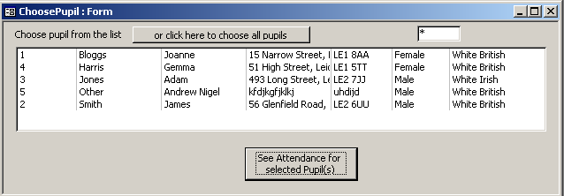
List box based on Pupil table, sorted by name.

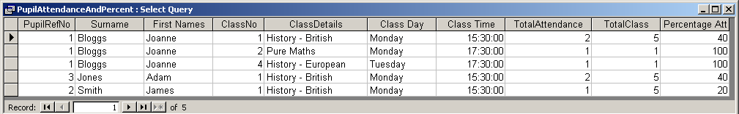

The query is built upon several other queries:
- PupilAttendance
  - The query is a simple Inner Join (the default join in Access) query, so will only show classes that have been attended by the pupil at least once. It will need to be changed to an outer Join query to show all Classes on which the Pupil is registered.
  - The criterion for the PupilRefNo uses an IIF function to select just the selected pupil or to select all pupils, using the value in txtPupilRefNo on the ChoosePupil form.
- TotalClassOccurrence
  - This is an aggregate query which counts up the number of registers that were taken for a class.
- PupilAttendanceAndPercent
  - This is a simple Inner Join query.
  - It selects all columns from the PupilAttendance query, plus the TotalClass column from the TotalClassOccurrence query.
  - The PercentageAtt column is a calculated column to work out the percentage attendance so far for each student on each class shown.

See section 3.6 of the ‘Getting Started’ VBA Trainer for more information on how to code for list boxes on forms.

How some of the other queries work

AttendanceRegister_Crosstab

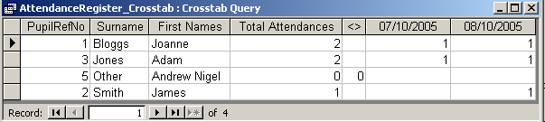
This query is called from the ChooseClass form and shows which pupils have attended on each of the days that the selected class has run, with a total of attendances per pupil.
Dates on which an attendance has been recorded.
This Pupil has not attended anything.
The query is built upon several other queries:
- PupilsByClass – also used in the AttendanceRegister query and form.
  - As this query will eventually be used in a Crosstab query it is not possible to use a Forms Collection reference for the ClassNo parameter. So a NOT IN subquery has been coded, using the ClassNo table, which has had the value set up in the cboClassID_AfterUpdate event on the ChooseClass form.
- AttendanceRegisterAllDates
  - This is an Outer Join query to select all pupils from the PupilsByClass query and any matching attendances from the Attendance table.
  - This will list all pupils registered on the class, and all recorded attendances and dates for that class. Pupils who have not attended will be shown without attendance details.
- AttendanceRegister_Crosstab
  - This is a wizard Crosstab query based on the AttendanceRegisterAllDates query.
  - The sort order has been added afterwards.

PupilsForAllClasses - all Pupils

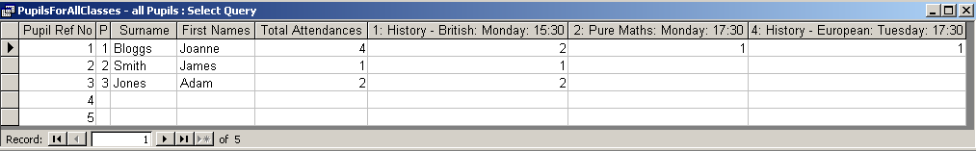
This is currently a stand-alone query, and shows the attendances of all Pupils in the database across the modules for which they are registered.

The query is built upon several other queries:
- PupilsForAllClasses
  - This uses all four data tables, selecting details of Pupils and Classes on which they have attended.
  - It will not select pupils who have not attended anything.
  - The various Class table fields that make up the details of the Class have been concatenated into one field, as only one field is allowed for a Crosstab query column.
- PupilsForAllClasses_Crosstab
  - A wizard Crosstab query based on the PupilsForAllClasses query.
- PupilsForAllClasses - all Pupils
  - This is an Outer Join query of the PupilsForAllClasses - all Pupils query and the Pupil table, with the join set to select all Pupils and matching Attendances if any.
  - The columns in a Crosstab query will vary each time it is run, as it picks up the data values in the tables used. Therefore, this query selects all columns from the Crosstab query by using the * facility (click on the * row at the head of the query icon in the top half of the query design window). This also means it gets two columns for the PupilRefNo, but you can change the column width so that the extra column does not show.
Saving query results

Query dynasets can be saved to a spreadsheet if wanted. This can be done by simple copy-and-paste for users who know how to do this, or via VBA code with DoCmd.TransferSpreadsheet. This is very easy to use, and there is some discussion of it with an example in the ‘Getting Started’ VBA Trainer, section 7.3.5.

More information on using a Crosstab query

See the ‘Getting Started’ VBA Trainer, section 8.4.

Can’t enter data in a form

Some of the queries here are quite complex. If you have a complex query to be used for a data entry form (such as the AttendanceRegister form here) and then find that you can’t make changes to data via the form, then see Access Frequently Asked Question 28 Why can’t I enter data into my form? on http://www.cse.dmu.ac.uk/~mcspence/Access.htm

End of notes.

