Design considerations

The first thing is to consider the various elements that make up a CD.
- CDs come in sets of two or more CDs, or as singles (singles can be thought of as sets of one CD).
- Each CD has one or more tracks. The number of tracks varies from CD to CD.
- Each track will be performed by one or more artists.
- Information may need to be kept on other items, such as the producer, release date (track and/or CD), date bought, where bought, titles (CD set, track).
The exact details may vary according to the nature of the Collection.

From the above, the following identify themselves as entities:
- CD Set.
- CD Disk.
Each Set has one or more disks.
Each Disk belongs to only one set.
thus Set:Disk = 1:m relationship
- Track.
Each Disk has one or more tracks.
Each Track belongs to only one disk
thus Disk:Track = 1:m relationship
- Artist.
An Artist may appear on more than one track.
A Track may have more than artist.
thus Track:Artist = m:m relationship
For these databases, I have assumed that the track title is an attribute of Track, rather than a separate entity. This assumption could apply to a general and varied collection (as although some duplication may well occur, there will not be much), but it may be incorrect for collections of specific types of music.
I have also used a catch-all attribute of 'Details' for the CD and Track entities, for simplicity here.

CD Collection - version 1

This is just a simple implementation, assuming (unrealistically) that each Track has only one Artist. There is no separate Artist table, so, depending upon the nature of the Collection, there could be some (or even quite a lot of) duplication here.

There are three data tables. Relationship diagram is:
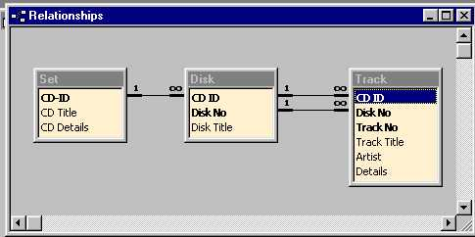

There is also a 'Read me' table, with some further explanation.
The Disk and Track tables demonstrate the use of composite keys. This seemed (to me) to be a fairly logical thing to do initially, but it can make joins and the use of combo/list boxes on forms rather tricky.

The input form (Set) has a subform (Disk) which itself has a subform (Track). There is no code behind the form.

There are some simple queries: select everything; select by artist; select by title. Parameters ([please enter...]) are used for (an exact match with) the artist and title.

There is one report, listing everything. This is shown as provided by the wizard and after customisation. There is no code behind the report.

CD Collection - version 2

This version has implemented the m:m relationship between Track and Artist, by introducing an Appearance table. See relationship diagram:
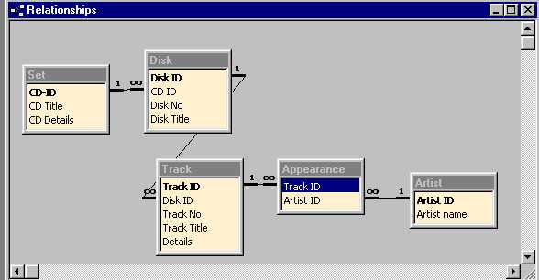

There is also a Read me table (with a Read me report to make reading the table easier) with further explanation.

This version illustrates several points:
- How to resolve a m:m relationship.
- Using AutoNumber primary keys on all tables.
- VBA code in the form modules:
  - for adding artists for a track (uses artist [sub] form)
  - for viewing/adding artists and for adding tracks (uses track [sub] form)
- Using outer joins for queries by artist/title.
  - When a Set or Disk is for just one artist, it seems pointless to have to enter the artist name for each track. So I have allowed for these tracks to have the artist name left null, and for the artist name to be in the title field instead. Queries using the artist table must now use an outer join. See What is an outer join on the FAQ page for an explanation and example of outer joins (these joins can be very useful!). The artist query selects either the track name or the name in the title. Both queries use LIKE to match the start of the name/title.
- Suppressing blank lines in a report.
  - Following on from the above, where the artist name is left null for a track there will be a corresponding blank line on the list report. So VBA code is used here to suppress these blank lines.

