Use Access/VBA Help and the Debugger to find out more about these items.

If you discover any more differences, please email mary.spence@dmu.ac.uk

Access 2000
Two New Date Functions
Round Function
Splitting messages over several lines
Sgn (sign) Maths function
General information regarding the use of Data Access Objects (DAOs)

Access 2002
List Boxes
Table field changes, effect on bound form fields
Range used for Century defaults

Two new date functions.

WeekdayName – takes the day number (1-7) and converts it to the day name (Sunday, Monday, etc).
You will need to specify Sunday as the first day of the week (use VB Constant vbSunday), or else this will not give the correct result.
See section 3.2.1 of the ‘Getting Started with VBA’ Trainer, which was written using Access 97. This asks the reader to create a function myGetTodayName, but this can now be done very simply using the Weekday and WeekdayName functions.

MonthName – takes the month number (1-12) and converts it to the month name (January, February, etc).

Round Function

New for Access 2000. This function was not available in Access 97.

For further information see the Getting Started VBA Trainer and VBA FAQ 13 (details on http://www.cse.dmu.ac.uk/~mcspence/Access.htm).
It does not work quite as you would expect it to, but Access Help does not discuss this fact!

Splitting messages over several lines

See sections 4.4.1 and 4.5.3 of the ‘Further VBA’ Trainer, also written using Access 97. The method illustrated here was explained in Access 97 help, but does not work in Access 2000/2002 – the @ signs now appear in the message!

In order to split a message over more than one line, use the VB Constant vbCrLf (carriage-return, line-feed). Example:
MsgBox ("First line" & vbCrLf & "Second line")
(But I don’t know how to display text as bold, italic, underline etc. in a message)

General information regarding the use of Data Access Objects (DAOs)
- The DAO Object Library needs to be installed in order to code using DAOs. To set this, do:
  - Open a code window
  - Choose Tools→References
(note that the Tools menu gives a different list to the usual one, for an open code window).
  - Click the checkbox for Microsoft DAO Library
(probably version 3.51 for Access 97 and version 3.6 for Access 2000).
- Access 2000 does not use DAOs, but uses ADOs (confusing!) instead. ADO stands for ActiveX Data Object. The Access 97 code shown in the VBA Trainers will all still work under Access 2000 with only one minor change - see the next bullet below. If you wish to see examples of the code that should be used for Access 2000, look at Help→RecordSet and then scroll down (near the end of the rather lengthy list) to the item titled Converting DAO Code to ADO.
- If you get a "Type Mismatch" error with RecordSets, then this is probably because you are using the Access 97 declaration in Access 2000. In Access 2000, you should code each declaration as Dim rstRecords As DAO.RecordSet
in place of Dim rstRecords As RecordSet
- When adding the DAO Object Library (see point 1 above), if you move the row to above that for the ADO Object Library, then it would appear that the DAO library is then checked first, and DAO code is then OK – the "Type Mismatch" error in point 3 may not then occur. However, it is probably good practice to code as suggested in point 3, as it could help future version-compatibility and maintenance.

List boxes

New for Access 2002: AddItem and RemoveItem methods.
These new methods apply only to list boxes where the RowSourceType property is ‘Value List’.
The RowSource property holds items separated by a semi-colon “;”.

Using AddItem:
To add to a list box with only column: lstOutput.AddItem Value1
To add where there are two columns: lstOutput.AddItem Value1 & “;” & Value2
Etc.

Where:
- The list box is called lstOutput
- Value1 etc are variables that hold the new values for the list box row.

Using RemoveItem
The code below assumes that the list box is called lstOutput.

Delete the last row | Delete the selected row
Dim intRowNo As Integer  intRowNo = lstOutput.ListCount - 1  If lstOutput.ColumnHeads = True Then  intRowNo = intRowNo - 1  End If  If Not intRowNo < 0 Then  lstOutput.RemoveItem intRowNo  End If | Dim intRowNo As Integer  For intRowNo = 0 To lstOutput.ListCount - 1  If lstOutput.Selected(intRowNo) Then  lstOutput.RemoveItem intRowNo  End If  Next

These two methods were not available in Access 97 or 2000.

Access 97 had a Clear method to clear a list box. This is no longer available, but it is very simple to clear the list box by coding:
lstOutput.RowSource = “” ‘ “” = the ‘empty string’

See also the Listbox97example database on http://www.cse.dmu.ac.uk/~mcspence/Access.htm

Sgn (sign) Maths function

Access 97: Function returned 0 if positive or zero, -1 if negative.
Access 2000/2002: Function returns 1 if positive, 0 if zero, -1 if negative.
Quite a difference!

Table field changes, effect on bound form fields

In Access 97 and 2000, when you created a form based on a table or query, all bound fields picked up their properties from the table. If you changed a table field, then you would have to make corresponding changes to the field on the form, or delete the field from the form then recreate it via the field list.

From Access 2002, all such changes made to a table are automatically reflected in bound fields on a form.
Range used for Century defaults

If you type a date with a two-digit year, MS Access will interpret the years as follows:
year 30 – 99 ➔ 1930 – 1999 (15/3/35 is taken to be 15/3/1935)
year 00 – 29 ➔ 2000 – 2029 (15/3/15 is taken to be 15/3/2015)

In Access 97 and 2000 the above range was fixed.
In Access 2002/2003 the range is a default, but you can now specify your own range. See the Microsoft knowledge base at http://office.microsoft.com/en-gb/assistance/HA010345721033.aspx the text at which is copied below:

Setting how your computer handles two-digit years in Access
Help

Assistance > Access 2003 > Startup and Settings

Applies to
Microsoft Office Access 2003
Microsoft Access 2002
When interpreting two-digit dates, Access makes certain assumptions based on the regional settings in Control Panel. You can alter the way Access interprets two-digit dates by changing these settings.
- Click Start, point to Settings, click Control Panel, and then double-click Regional Options (or Regional Settings).
- On the Date tab, click the arrows under When a two-digit year is entered, interpret as a year between to set the ending year.
Notes
- This feature has a 100-year span. The default span is 1930 to 2029. A program that uses the default option to interpret two-digit years will consider the years between (and including) 30 and 99 to be preceded by 19, and years between (and including) 00 and 29 to be preceded by 20. For example, 99 will be interpreted as 1999 and 01 will be interpreted as 2001.
- Four-digit years are not affected by this option.

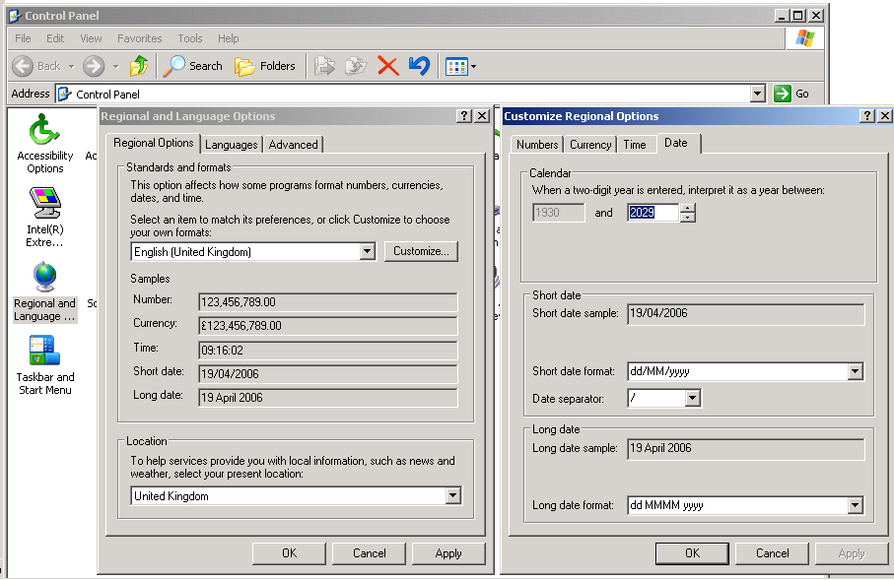

Date tab

