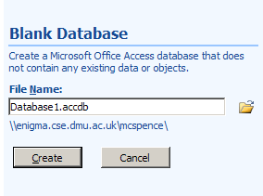
When you first open an MS Access blank database you are prompted to set a filename

If you leave the file extension as .accdb you will create an Access 2007 file format database. This will...
- ...not be able to be opened with earlier versions of MS Access.
- ...use macros as the default for wizard command buttons (and possibly other wizards) rather than generating VBA code.

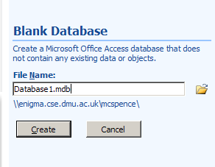
If you want to be able to use your database with Access 2002 or 2003, and/or want wizard code to be generated rather than use macros, then change the extension of your database to .mdb to get an Access 2003 format database.
See also the Help item Change the default file format. This option may not be available in DMU labs.
Sometimes you may prefer the code so that you can add something to it, e.g. an ‘Are you sure?’ question when saving or deleting.
This appears to work with record navigation buttons on forms – I’ve not tried it with anything else yet.

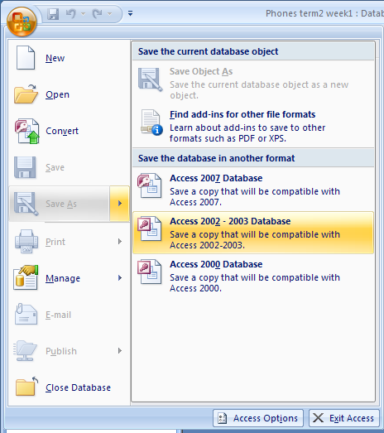
If you’ve already created an Access 2007 format database then use Save As to save to an earlier version.
See item on the next page before doing this, if you have already got some buttons created with macros.
If you want to use Access 2007 database format but with VBA code for wizard buttons then there is an option to convert macros to VBA code. This seems to work OK, but does not seem to set a marker for Access to assume that you want all future wizards to use VBA – you seem to have to tell it every time, which is a bit of a pain (if anyone can find out how to set this for all wizard-created controls, then please let me know!).
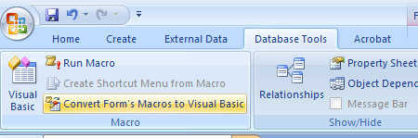
If you are using an Access 2007 format database, and create a wizard button, then to convert the macro to VBA code do the following:
With the form open in design view, click on the Database Tools tab and choose Convert Form’s Macros to Visual Basic.

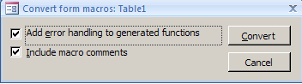
Then tick the appropriate boxes in the dialog shown here and click on the Convert button. The embedded macros should now be replaced by the usual VBA event procedures, with the change reflected in the property boxes (Event tab) for the controls.

There’s a lot of information about macros vs. VBA code in Help – search for Get started with Access programming or click on the link for Macros and programmability when the Help window first opens. The above was taken from the link for Convert macros to VBA code

