Mailing Letter example database

This example database was set up to demonstrate several methods of writing letters, in response to queries from placement and project students. The HCI is pretty basic, and the processes have not been fully tested. It is set up so that the menu opens automatically on open (see Tools→Startup).

The database is based on an optician practice (as that was the requirement for the database being implemented by the first student who requested help).

Several methods are demonstrated:
- Individual letter from the optician to the patient’s doctor, including the option to choose letter elements from drop-down lists.
  - Storing details of the letter for reference
  - Not storing details (one-off letter)
- Bulk letter for appointment reminders.
  - Allowing the user to type details in a form
  - Using mail merge with access to Word for the user to format the letter, based on a query where the appointment date is compared with …
    - … the system date
    - … a date parameter entered on a form

Each method is discussed in more detail on the following pages. Look at the form, report and Access code modules to see what is there. Ideas can be adapted from each method as necessary for your application.

The table below shows which objects are used for each method.

Object | Name | Stored Indiv letter | One-off Indiv Letter | Stored Reminder letter | Mail Merge using system date | Mail Merge using parameter
Table | Condition | ✓
Table | IndivLetter | ✓
Table | MailMerge |  |  |  |  | ✓
Table | OpticianName | ✓ | ✓
Table | Patient | ✓ | ✓ | ✓ | ✓ | ✓
Table | ReminderLetter |  |  | ✓
Query | qryMailMerge |  |  |  | ✓
Query | qryMakeMailMergeTable |  |  |  |  | ✓
Query | qryReminderLetter |  |  | ✓
Query | qryStoredIndivLetter | ✓
Form | frmMenu | ✓ | ✓ | ✓ | ✓ | ✓
Form | frmOneOffIndivLetter |  | ✓
Form | frmPatient | ✓ | ✓
Form | frmReminderLetter |  |  | ✓
Form | frmStoredIndivLetter | ✓
Report | rptOneOffIndivLetter |  | ✓
Report | rptReminderLetter |  |  | ✓
Report | rptStoredIndivLetter | ✓

Notes:
- For simplicity here the name and address fields on tables are not split into their separate components.
- The HCI is kept simple – it could be improved.

1. Individual letter from the optician to the patient’s doctor

Clicking on the individual letter button on the menu (FrmMenu) opens the Patient form (frmPatient), and the user can choose the appropriate letter type from here.

When you add a new patient, you will need to save the record before creating a letter, otherwise the letter cannot be created because there will not be a matching record in the Patient table. It would be good HCI to disable the ‘create letter’ buttons until such time as the patient details have been saved.

1.1 Storing details of the letter for future reference

The IndivLetter table is used to record details of each letter sent to each patient. The table is related to the Patient table via the Patient No. (See the relationships window).

The frmStoredIndivLetter form is based on the IndivLetter table, and allows the user to enter a new letter or edit an existing one.
- Buttons are set to disabled initially then enabled once appropriate actions have taken place.
- The date and time of last change is set as an invisible field on the form and updated at each save.
- There are two text fields with a drop-down box between them. The drop-down list is based on the Condition table. The user must choose from the list (see LimitToList property), but can also leave the box empty.
- The optician name is chosen from a drop-down list based on the OpticianName table, but the user can also enter another name (see LimitToList property). The code should check (but doesn’t here) at save that a name has been entered/chosen.
- The Form_Current event is used to copy the patient No to from frmPatient to frmStoredIndivLetter. This action is done here rather than in the Form_Load event to cater for the situation where the user moves to see previous letters then moves forward to the new letter, as the Undo statement in the Form_BeforeUpdate event will clear the Patient No each time.

The qryStoredIndivLetter query is created to use the required information from the Patient and IndivLetter tables for the actual letter, the rptStoredIndivLetter report.
- The report detail has three hidden fields with the Visible property set to No: [Letter Text], [Condition] and [Letter Text2].
- Code in the Detail_Format event combines the data in the three hidden fields (with spaces in between) and puts it in the visible [Combined Letter text] field.
  - If the Condition field is left null, then the effect is to combine just the two text fields, but with two spaces between them.
  - Better code would check to see if the Condition field was null and combine with only one space between the two text fields.
- See also how the Printed date has been formatted on the report – see the ControlSource property for the date on the report.
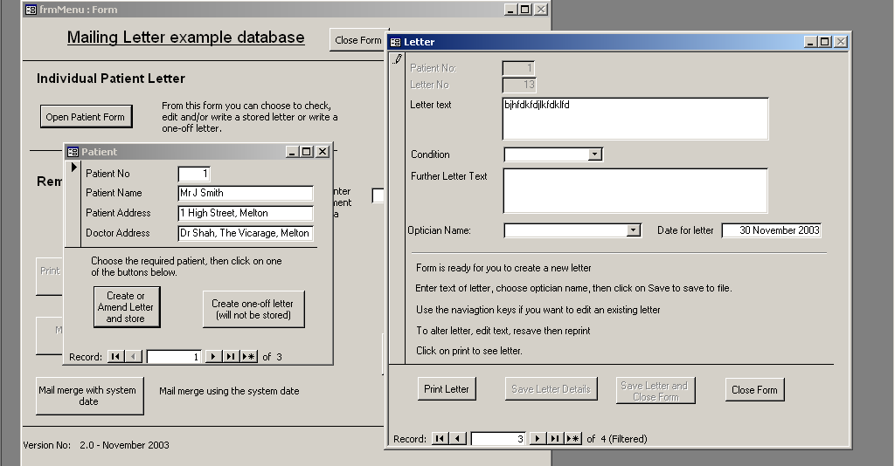

1.2 One-off letter where details are not stored.

This works in a similar fashion to the letter in 1.1 above, but does not save any details in a file and does not combine fields on the form. The form frmOneOffIndivLetter is opened from the frmPatient form but is not based on any table.

The rptOneOffIndivLetter report is also thus not based on any table. All controls are unbound, then linked to the appropriate field on an open form using the Control Source property for the field.

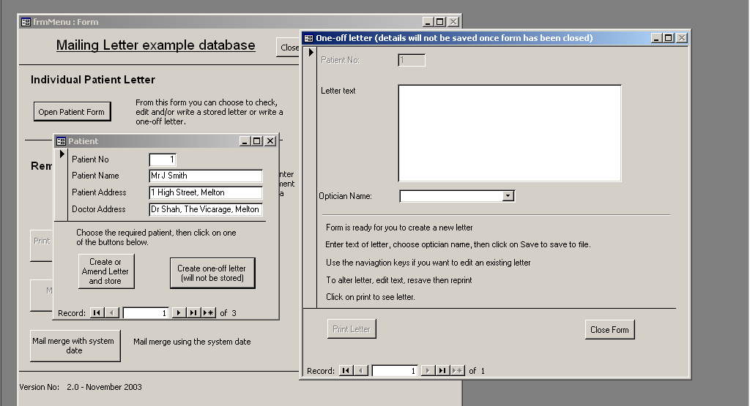

2. Bulk letter for appointment reminders

2.1 Letter constructed from details on a form

This is a very rough-and-ready example.

The ‘print reminder letters via a form’ and ‘mail merge with parameter’ buttons are greyed-out until the user has entered an appointment check date.

The form frmReminderLetter is opened from the main menu by clicking on the ‘print reminder letters via a form’ button. This form is based on the ReminderLetter table, where details of letters are stored (in a similar manner to method 1.1 above). This method allows for a record of letters sent to be kept, and letters could be reused. The user enters the relevant text and the appointment check date.

The report is rptReminderLetter which is based on the qryReminderLetter query which selects patients whose next appt date is before the check date specified on the form.

You may also need to ensure that letters are not sent repeatedly, possibly by having an [Appt Made] check box in the table (and using an Update query to set the value in the field), then change the qryReminderLetter query to select only those patients who have not made an appt yet. You could also stop sending letters after, say, 3 months.

The details do not need to be stored in a table – a method similar to that of method 1.2 above could also be used.

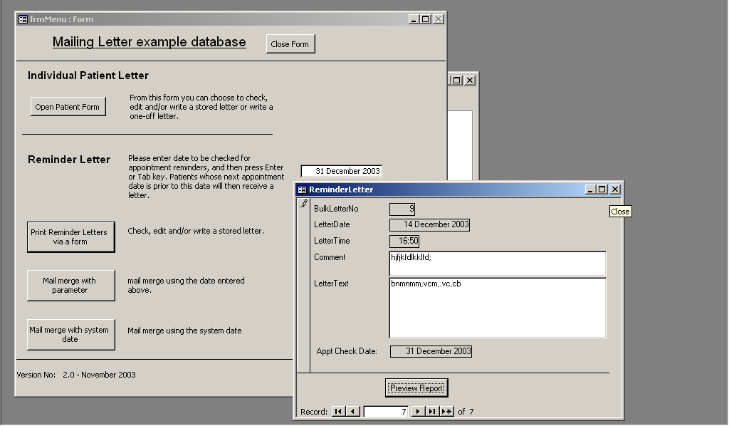
2.2 Using mail merge with access to Word for user to format the letter
See also Unit 19 of McBride ‘Access 97 Further Skills’.

To create a letter, do the following:
- Highlight (i.e. click on) the required table or query in the database window.
  - Note that Mail Merge does not appear to work on queries that use parameters based on a form. You will get a message saying that Access is unable to connect to the data source; Method 2.2.2 below shows a way of getting round this.
- Click on the Office Links icon on the Access toolbar and choose Merge it with MS Word.
- From the Wizard dialog box, choose Create a new document and then link the data to it.
- The Wizard now guides you though several steps:
  - Step 1 – select document type
    - choose ‘letter’ from the right-hand pane and click on Next
  - Step 2 – starting document
    - Choose ‘use the current document’ (a blank page) and click on Next
  - Step 3 – select recipients
    - This should confirm that your report is based on the required table or query. If not, close Word (without saving) and start again.
    - If you click on ‘Edit recipient list’ you will see the records that have been selected by the query.
  - Step 4 – write your letter
    - Add the text that you wish to appear on each letter
    - Add the fields from the table that you wish to appear on each letter – choose these from the Insert Merged Fields icon (looks like a field list icon) on the Mail Merge toolbar.
  - Step 5 – preview your letters
    - You should now see the first letter in the set to be printed. Use >> and << in the right-hand pane to scroll through the letters.
    - The date may show in mm/dd/yyyy format. I don’t know how to change this easily. One method is to have separate columns for each element in the query and format the date yourself in the letter.
  - Step 6 – complete the merge
    - Save your letter as MailMerge Reminder Letter then close Word. It seems logical to save it in the same directory as your database, though this would not appear necessary. It might be simpler to put it in the default My Documents directory then it is easier for the user to locate when Word is opened.
  - Your letter has now been created. See 2.2.1 for how to use it.
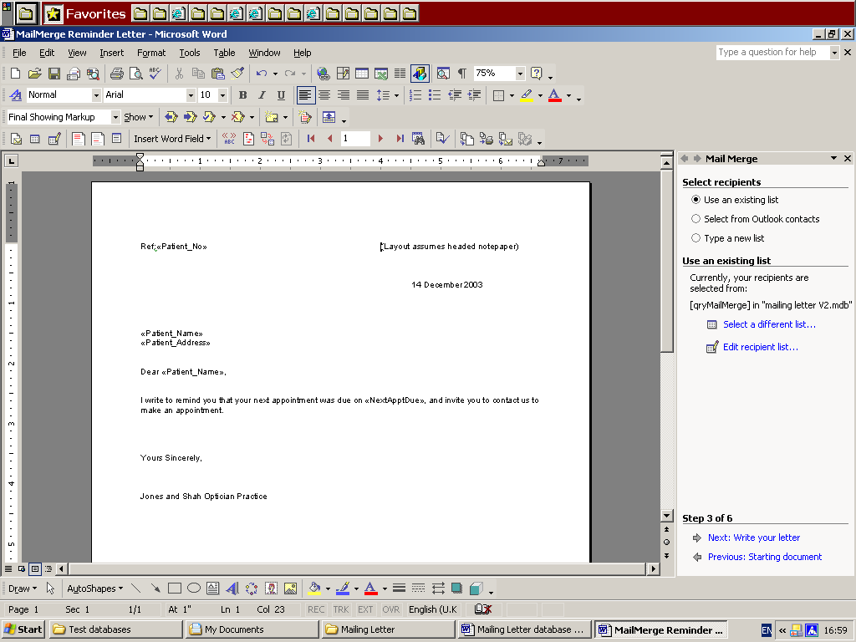

2.2.1 Mail merge letter based on a simple query

Create a letter based on the qryMailMerge query. This query selects patients whose next appointment date is before the system date.

Open the menu, and click on the ‘Run Word to use Mail Merge’ button. This will open Word. [This is a wizard command button - choose category ‘Application’ then ‘Run Word’]. The button is called cmdRunWord.

Instructions can be seen by clicking on the instructions button on the database menu.

By this method, a standard letter can be set up by the database administrator and then accessed from within Word by the user, and amended if necessary.

If you get problems with accessing the file, try restarting the machine and trying again. My version of Access 2002/XP seems to have a lot of problems with locking, and these are (normally…) cleared if I reset the machine and start again.

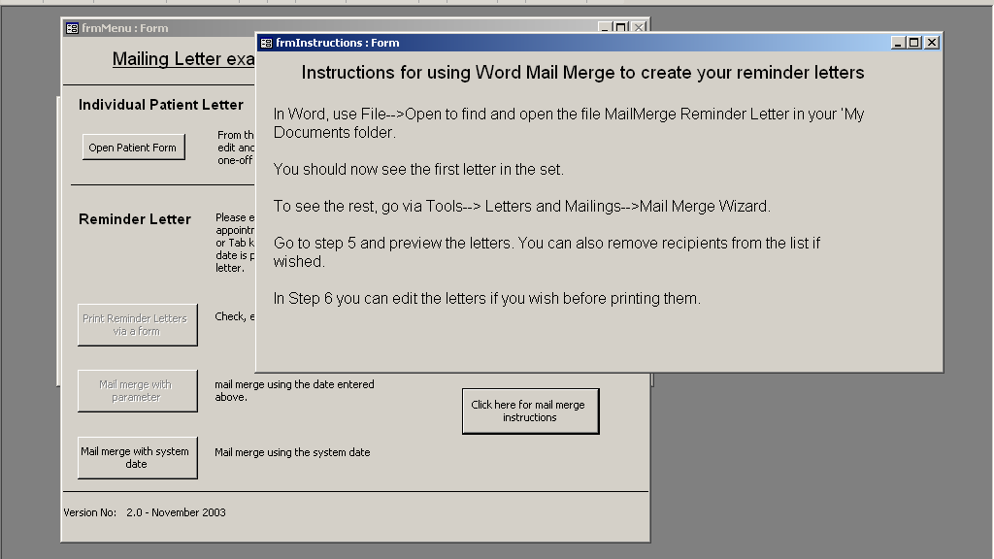
2.2.2 Mail merge letter based on a parameter query

If you try to use a query using the date from the menu form as a query criterion Word will not be able to connect to the data source. It will be able to find the database, but not the field on the menu.

Many useful queries require parameters from forms (i.e. those that the user enters at run-time).

A way round this restriction is to:
- Run a make-table query which selects the required records using the form date and write the records to a new table.
  - The query qryMakeMailMergeTable was created for this purpose.
  - The button ‘Mail merge with parameter’ was created by the command button wizard to run qryMakeMailMergeTable.
  - The code for cmdRunWord was called from the ‘Mail merge with parameter’ button (i.e. added to that wizard code) to open Word.
  - Now, when the ‘Mail merge with parameter’ button is clicked, a new table MailMerge is created and Word is opened. See the code for cmdMakeMailMergeTable_Click.
- Use this new MailMerge table as the data source for your mail merge Word document.

However, there are several Access messages that will pop up if you use this process:

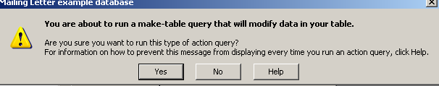
1. A warning that you are about to run a make-table query.

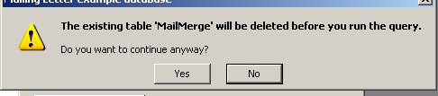
2. A warning that an existing table with the same name will be deleted in order to create the new table.

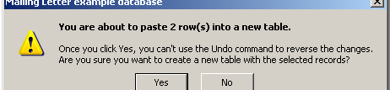

3. A warning that you are adding rows to the new table.

Messages 1 and 3 are easy to suppress – the information below is from MS Access Help. You simply untick the Action queries checkbox (but note that this will also affect any other action queries that your database may run).

Turn confirmation messages on or off
- On the Tools menu, click Options.
- Click the Edit/Find tab.
- Under Confirm, do one or more of the following:
    - To display a confirmation message when you change a record, select Record changes.
    - To display a confirmation message when you delete a database object, select Document deletions.
    - To display a confirmation message when you run an action query (Access database only), select Action queries.

To get rid of message 2 you need to check if the table has been created. The Boolean variable MailMergeTableCreated (see declaration at the top of the frmMenu code) is used as follows:
- Set to False when form loaded, to indicate that the table has not yet been created.
- Set to True when the MailMerge table is created in cmdMakeMailMergeTable_Click.
- Checked in the following two situations, and, if true, the MailMerge table is deleted:
  - Prior to running the qryMakeMailMergeTable
  - When closing the form (this is the reason for the Close button on the form – the Form_Close event does not appear to be activated when the X on the form is clicked to close it).

Now, when the user clicks on the ‘Mail merge with parameter’ button, the query qryMakeMailMergeTable is run using the form date, the new table MailMerge is created and Word is opened. The new table is deleted when the menu form is closed. All this should happen without the user being aware that anything different from usual is going on.

So, create your letter based on the MailMerge table, using the instructions in section 2.2 above.
(Hint – comment out the code that deletes the table in the procedure cmdClose_Click in frmMenu then you will have a table to use. Then delete the table and reinstate the code).

End of explanatory notes.

