The Calendar Control available in previous versions of Access has been removed from Access 2010.

If you open a database created in a previous version of Access in Access 2010, and then open a code window, you may see the following message:
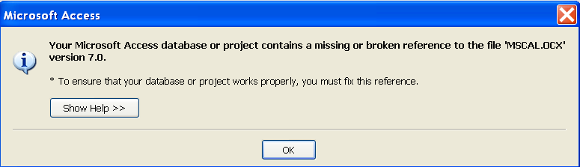

MSCAL.OCX is (was) the name for library reference for the calendar control.
Click on the Help button and see the information there.
Your database may not use the Calendar Control, but you may still get this message.
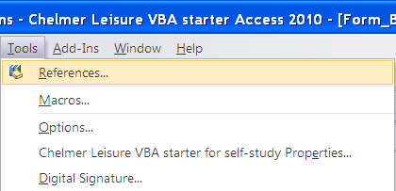

To fix this error, go via Tools→References on the menu:

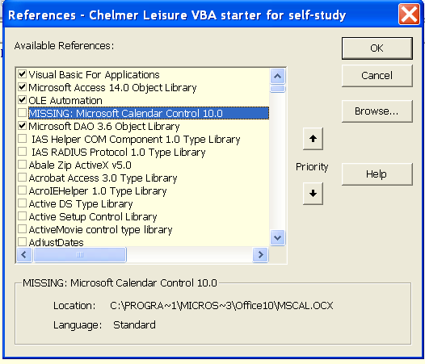

Then untick the item marked as MISSING:

And click on OK.

This should fix the problem and stop the message appearing.

However, if your database uses the Calendar Control on any form you will have to redo that form, perhaps to use Access’s own date picker or 3rd-party calendar controls available on the Web.

