Report Design Sorting and Grouping

This is completely different from the nice little dialog that was available in Access 2003 or earlier.
In Access 2007 you need to do the following:

1. Open the report in design view.
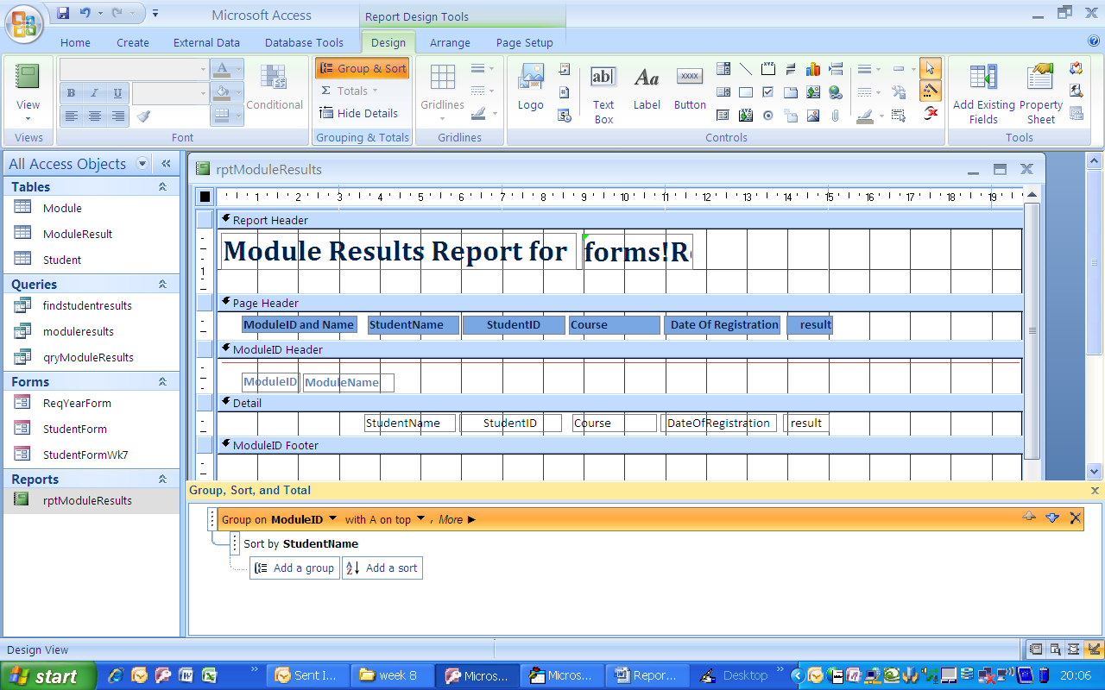
2. Select the sorting and grouping tools (Report Design Tools, Design tab):
3. Select the required group and click on more options. (This report only has one group; some reports will have several).

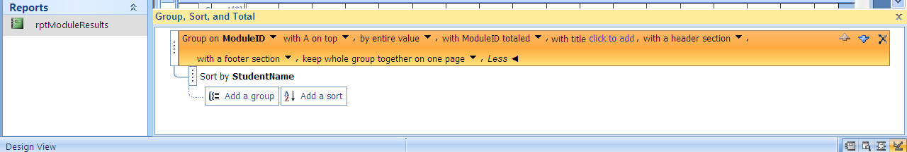
4. Choose the required options (for example: ‘with a footer section’ and ‘keep whole group together on one page’.
Click on the cross to delete the grouping.

4. Close the sorting and grouping dialog.

