An Introduction to SQL in MS ACCESS

For students on CSCI1403

Introduction to Database Implementation

This document is to be used for self-study during weeks 4, 5 and 6 of CSCI1403.
You are expected to complete all the exercises.

Week 4: Pages 4 -14 (including exercises A and B). Much of this should be familiar to you from the work done so far on queries.

Week 5: Pages 15 -19 (including exercises C, D, E).

Week 6: Pages 20 -27 (including exercises F and G)

SQL is a vital component of all database work (look at all the job adverts that require a sound knowledge of SQL!) and will be used again in this module, in the spring term with VBA coding. It will also be required for the end-of-year examination.

SQL will be used again in Year 2 of your Course, on the Database Design module, and is also necessary for some of the Final Year modules.

This Guide was written by Karen Burrow
(with CSCI1403 additions and changes by Mary Spence)
and is based on the SQL trainer
developed by Nigel Roberts
De Montfort University
Faculty of Computer Sciences and Engineering

Leicester

SQL – AN INTRODUCTION…………………...……………..………………………………..3
Guide Structure 4
Preparation for using the SQL View 4
SELECT 5
EXERCISE A 6
WHERE Clause 7
WHERE with logical AND, OR 8
Combined AND & OR 9
ORDER BY - ordering or sorting the output 10
Multiple Ordering 10
More on the WHERE Clause 11
BETWEEN 11
LIKE 11
IN and NOT IN - set operators 12
NOT IN - provides the reverse of IN 12
DISTINCT 13
NULL 13
EXERCISE B 14
UNION - of two SELECT statements 15
EXERCISE C …. …...16
MAX 17
COUNT 17
EXERCISE D 18
GROUP BY & HAVING 18
HAVING 19
JOINING TABLES 20
EXERCISE F 24
SUB QUERIES 24
UPDATE 25
DELETE 26
EXERCISE G 26
INSERT 27
EXERCISE H 27
Appendix 1: Data for the Chelmer Leisure Database 28
APPENDIX 2: RELATIONSHIPS WINDOW - Chelmer Leisure Centre………………....31
Appendix 3: SQL PROBLEMS 32

SQL: An Introduction

The most popular and now standard language for manipulating data in a relational database is SQL (initially called Sequel). The letters stand for Structured Query Language. This guide attempts to address the features found in today’s SQL environments.

When using MS Access it is possible to use query by example (QBE), by designing queries via the Query Design Window. This is adequate for many users and is what most of you will be familiar with. With QBE the user fills in a table; this allows the user to say what fields (data items) they wish to be shown and the selection criteria used to select the data rows of interest. Other database software does not allow the user to do this; SQL is used. Access allows the user to write a query in SQL if they wish, or to use QBE. However when using QBE what is actually happening is that Access is converting the users ‘Table’ to SQL. Take a look at some of the queries you have written using QBE so far (to do this open the query by clicking on it, the result of the query should appear on the screen, click Design and select SQL view from the View menu)
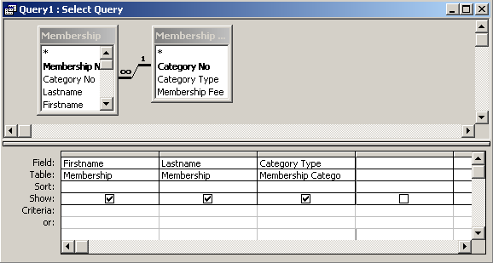
Example: query to show the names of members and their membership category
Create this query in QBE, save it.
Display the results on the screen by opening the query.
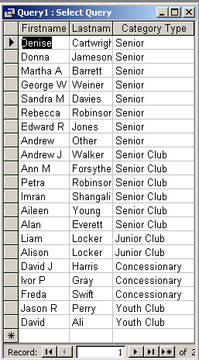

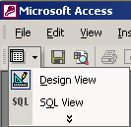
To look at the SQL click on the Design icon in the top left-hand corner of the screen, immediately below FILE on the menu list.
From this a selection of options will become available.

Click on SQL View and the screen shown below will be displayed. You can also click on View and select SQL View from the drop down menu that appears.
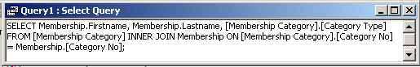

The purpose of this guide is to teach you to write these statements. The advantage of SQL is that it is very structured with a limited number of words to learn. More complex queries may be easier to write directly in SQL and correcting errors is often easier in SQL.

This guide is designed to introduce the reader to SQL; this may help the reader in the future to write SQL statements in later modules, when on placement, in project work and eventual employment. You will also need to know SQL for using SQL with VBA statements later in the module.

Guide Structure

This guide covers data retrieval and concentrates mainly on the SELECT statement. The final section covers the UPDATE, INSERT and DELETE statements. There are many other SQL statements as well, but these are not covered here. The examples and exercises in this guide are based on the Chelmer Leisure database, the scenario used in McBride (Access 2000 Further Skills).

As you work through the guide you should attempt all the examples and exercises. As you work through the examples try to understand them and predict the outcome of each query before you run it.

Preparation for using the SQL View

Access allows users to use spaces and other characters in field and table names, and McBride has taken advantage of this with the tables for the Chelmer Leisure database. Although this is not a problem in Access, other database software may not allow this. When using the SQL view in MS Access you will need to use square (not round!) brackets with all names that include spaces to show that the name is all one word (e.g. [Post Code], [Membership Category]). If you look at the SQL generated by the Query Design Window you will see that Access has automatically put the square brackets in the code, and sometimes this will happen with your own SQL after you have looked at the result in the Query Design Window.

When you come to create your own databases for assignment work and projects, you may prefer to use names that do not have spaces or other characters within them, for example:
Postcode | MembershipCategory | RoomOrHallOrCourt
Post_code | Membership_Category | Room_Hall_Court

The database tables with data are shown in Appendix 1 of this guide; you will be able to see the names used in the database that generated the SQL in this guide.

SELECT

This is the basic SQL data retrieval statement. It has the following format

SELECT <column, …>
FROM <Table, …> ;

The SELECT and FROM clauses must appear in every SQL command; i.e. they are mandatory. The statement is also ended with a semi colon - ';'.
(Access is not always fussy about having the semi-colon, but other database software is).

The simplest SQL command to query a relational database could be like this
With names without spaces:
Select MembershipFee
From Membership_category;
With names used in McBride:
Select [Membership Fee]
From [Membership Category];

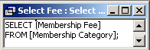
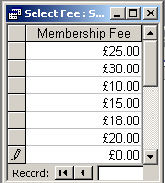
To write this query select New Query in Design view, close the table dialog box without selecting any tables and click on the SQL view from VIEW option from the top line of icons. This brings up the SQL screen. Type in the command (the stuff in italics only) as above and close and save in the normal way, giving the query a name when prompted.

Open the query. This should give the result shown here.

In other words the query has selected the contents of the Membership Fee column from the table called Membership Category.

If we want to see all the columns in a table we could write them all explicitly, as follows:

SELECT [Category No], [Category Type], [Membership Fee]
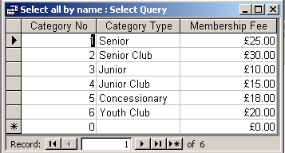
FROM [Membership Category];

Try this now and see the result. Note the commas between each field name in the SQL.

An alternative way of writing this, if you want all the fields or columns from a table, is:

SELECT *
FROM [Membership Category];

Try this; you should get the same result as above.
The * acts as a wildcard indicating that all available columns should be shown.

The correct way to specify a field name in SQL is:

Table_name.field_name

If you are only using one table, SQL knows which table the columns belong to, so you do not need to put the table name in the SQL.
When you create queries via the Query Design Window, Access will always put the table name in, even when there is only one table used in the query.
When there is more than one table the table name becomes important; more about this later.

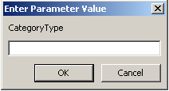
If you enter the wrong name for a field you will be prompted by a parameter box as shown here.
In this example CategoryType (all as one word) has been used in the SQL instead of the correct name of [Category Type].

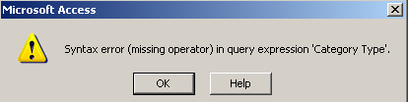
If you typed Category Type without putting square brackets around the name, you would get this error message:

EXERCISE A

Write SQL queries to retrieve the following details…

1. … all the first and last names of the members of the Leisure Centre.
2. … all the products the Leisure Centre sells. (You will need to add the Stock Level table to your database – see Appendix 1)
3. … all details about classes.

WHERE Clause

Copy and run all of the examples in this section, Check your output against the table data. Look at the query in Design view to see how it is shown in the Query Design Window, and to appreciate how the SQL and QBE work together.

The WHERE clause applies to individual rows in the table mentioned in the FROM clause. Each row is tested against the condition on the WHERE clause. If the condition is true it is included in the answer otherwise it is ignored.

Suppose we wanted to retrieve the names and telephone numbers of members who have concessionary membership (i.e. Category No 5).
In this case we would include a WHERE clause with a condition. This condition would be tested for each row of the table and only those that were true (i.e. have Category No=5) would be included in the answer.

1 SELECT Firstname, Lastname, [Telephone No]
FROM Membership
WHERE [Category No] = 5;

If we wanted details of stock items where the number in stock is less than 10

2 SELECT *
FROM [Stock Level]
WHERE Stock<10;

And for stock items where there is 10 or more items in stock

3 SELECT *
FROM [Stock Level]
WHERE Stock>=10;

When using text fields (strings) in conditions the text must appear between quotation marks, for example: Retrieving contact details of all members with the last name Locker

4 SELECT Firstname, Lastname, Street, Town, County, [Telephone No]
FROM Membership
WHERE lastname="Locker";

The traditional relational Comparison operators are:
= equality
<> not equal to
> greater than
< less than
<= less than or equal to
>= greater than or equal to

WHERE with logical AND, OR

More than one search condition may be specified within the where clause. For this we can use AND and OR.

OR
If we wanted the addresses of members whose names are either Walker or Perry the SQL would be

5 SELECT Firstname, Lastname, Street, Town, County, [Post Code]
FROM Membership
WHERE Lastname="Walker" OR Lastname="Perry";

When using Or only one of the conditions need to be met.

What this means is that each row of the table is tested at a time and if it meets the condition it will appear in the result. To meet the condition the surname must be either Walker or Perry.

Note that because the field is a text field the contents of the field you are testing for is in quotes. Remember that SQL can be case sensitive, especially when looking for matching text; this means you would not get any members details if the lastname were ‘walker’ or ‘WALKER’ for example. (This is a good reason for including formatting when designing your database to ensure that they all start with a capital letter regardless of what the user types). However, SQL in MS Access is not case sensitive.

Note. The following WHERE clause does not give the required answer (try it and see what happens):

WHERE lastname=”Walker” OR ”Perry”

You must give the full condition every time, as in the previous example.

AND

The AND operator works in a similar way, except that each row of the table must meet all the conditions in order to be displayed in the results. Example

6 SELECT *
FROM bookings
WHERE [Room/Hall/Court] ="Fitness Suite" AND Date=#13/5/96#;
Note:
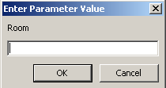
- The hash (#) enclosing the date field’s value; you may not need the # in other versions of SQL, but you must use them in Access.
- The square brackets around Room/Hall/Court; these are required because of the forward slash characters. The parameter box here shows what happens if you miss the square brackets off.

Example: Find details of all weight training classes which don’t have Franks as the class tutor

7 SELECT *
FROM Classes
WHERE [Class Activity] ="Weight Training"
AND [Class Tutor] <> "Franks";

Combined AND & OR
AND & OR can be combined but this will need brackets in order to make sure the correct clauses are being evaluated.

For Example Find details of all bookings in the Fitness suite on the 13/5/96 or 17/5/96.

8 SELECT *
FROM Bookings
WHERE [Room/Hall/Court] = "Fitness Suite"
AND (Date=#13/5/96# OR Date=#17/5/96#);

The brackets are used to show which operators go together; the brackets are tested first, just like in programming. If the brackets are missed off, then those conditions joined by AND are evaluated before those joined by OR.

For example, are these the same thing?
- WHERE [Room/Hall/Court] =”Fitness Suite” AND Date = #13/5/96# OR Date = #17/5/96#
  - This expression has no brackets, so the two conditions joined by AND will be evaluated first by default, so this is the same as number 2, which may or may not be is what is intended.
- WHERE [Room/Hall/Court] =”Fitness Suite” AND Date = #13/5/96#) OR Date = #17/5/96#
  - This will select the following:
    - All bookings for Fitness suite on 13/5/96
… and …
    - all bookings for any room on 17/5/96
- WHERE [Room/Hall/Court] =”Fitness Suite” AND (Date = #13/5/96# OR Date = #17/5/96#)
  - This will select the following:
    - Bookings for Fitness Suite only …
    - … on either of the two dates

Be careful with the use of AND & OR, Make sure you know what you expect the answer to be before you run the query when you are testing. It is very easy to use AND when you mean OR and vice versa. This shows how important it is to test your queries properly.

ORDER BY - ordering or sorting the output

Output of row order from SQL queries depends on the internal storage arrangement of the data; tables are just a set of data in no particular order. If you wish to be sure of a sequence of output then the ORDER BY clause is added to the basic SQL statement.

For example if you require Member details ordered alphabetically by lastname, your query should be as follows:
SELECT Title, Firstname, Lastname, [Date of Birth]
FROM Membership
ORDER BY Lastname;
(The default sort order is Ascending order)

Multiple Ordering
Details of all Members would be retrieved in lastname order and firstname order where the lastname were the same by using the following SQL query. This is often referred to as ordered by firstname within lastname, or lastname as major key and firstname as minor key.
SELECT Title, Firstname, Lastname, [Date of Birth]
FROM Membership
ORDER BY Lastname, Firstname;
Try this query, alter the ORDER BY clause and look at the difference (look at the rows for lastname = “Locker”). Try adding ORDER BY clauses to some of the previous queries.
ORDER BY always goes after a WHERE clause, but not necessarily immediately after (see later - GROUP BY clause).
The default order is ascending (e.g. increasing number value or increasing alpha numeric sequence, depending on the type of the attribute). To reverse the order, DESC has to be put after each attribute listed in the ORDER BY clause.
Example: Name and date of birth of all junior members (i.e. Category No 3 or 4)
SELECT Title, Firstname, Lastname, [Date of Birth]
FROM Membership
WHERE [Category No] =3 OR [Category No] =4
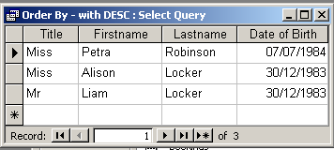
ORDER BY [Date of Birth] DESC;

More on the WHERE Clause
Complete all the examples in this section, and check your answers after you have completed them.
As well as the traditional relational comparison operators (e.g. =, < >, >, < ) and Boolean operators (e.g. AND, OR), there are additional operators such as:

BETWEEN
e.g. SELECT *
FROM [Stock Level]
WHERE Stock BETWEEN 10 AND 50;
The WHERE condition here is equivalent to

Stock >= 10 AND Stock <= 50;

LIKE

e.g. SELECT Title, Firstname, Lastname, [Date of Birth]
FROM membership
WHERE Lastname Like "W*";
Also Note the “ ” embracing a character string. All character strings need to be embodied in quotation marks to denote their character status, as in other programming languages.
A * (asterisk, star) is a string match expression value, indicating any sequence of, in this case, characters. (Also known as a ‘wildcard’).
'P*' Looks for any character string starting with 'P'.
'*P*' would look for any character string with a 'P' somewhere in it.
Implementations of these aspects may vary considerably between different DBMSs. (% is a common substitute)

IN and NOT IN - set operators
These are used to find rows where values of the required attribute match any one of a set of values, or fail to match any of the set of values.
1 SELECT *
FROM Bookings
WHERE [Room/Hall/Court] IN ("Sports Hall 1", "Sports Hall 2");
This would look for details of all bookings in the two Sports Halls.
An alternative clause in this example could be
WHERE [Room/Hall/Court] LIKE "Sports Hall*";

NOT IN - provides the reverse of IN

2 SELECT *
FROM Bookings
WHERE [Room/Hall/Court] NOT IN ("Sports Hall 1", "Sports Hall 2");
Finds all books details of all bookings that are not in either of the two sports halls.
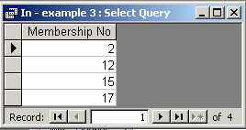
This can be especially useful for finding details that are not recorded in a database. For example, to find details of members who have made bookings, code:
3 SELECT Membership.[Membership No]
FROM Membership, Bookings
WHERE Membership.[Membership No] =
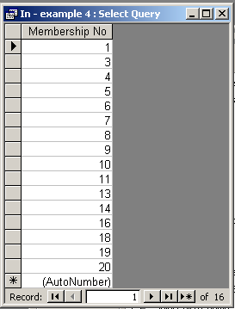
Bookings.[Membership No];

And to find details of members who have not made bookings code:

4 SELECT [Membership No]
FROM Membership
WHERE [Membership No] NOT IN (
SELECT Membership.[Membership No]
FROM Membership, Bookings
WHERE Membership.[Membership No] =
Bookings.[Membership No]);

As the members either have made bookings or have not made bookings, knowing the set of members who have made bookings (from the data in the database) we can find out the set of members who have not made bookings, by using what is known as a sub query. The sub query is shown in bold italic font in the SQL for example 4 above, and is the same as example 3 (the set of members who have made bookings). The two datasets between them make up the set of all members.

DISTINCT

Some SQL statements may result in table outputs that have duplicate rows. For example, list the names of all class tutors currently taking classes.

SELECT [Class Tutor]
FROM Classes;

Try this query and look at the output; the output obtained does not really answer the question.
To eliminate duplicates, the DISTINCT operator is applied to the column in the SELECT statement. This will remove all duplicates, i.e. each name will only appear once.

Note you need to use this operation carefully because the database has no way of knowing if the fields are the same or not; you could have two tutors with the same name, but this operator would treat them as the same thing and remove some of the results table rows. This is why it is better to collect this information from the Tutor table. It would be even better if the database had a TutorId field, as it is quite possible to have two Tutors with the same name. With the current example, if telephone number, address and the full name were included, any rows extracted from the database which contained the same values for all the fields would be true duplicates.
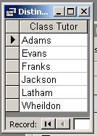
SELECT DISTINCT [Class Tutor]
FROM Classes;

If you create a query via QBE that results in duplicate rows (for example, listing all members who have made bookings in a particular period) then you can go to the SQL window and add DISTINCT after SELECT to remove duplicate rows.

It can be very useful to start a query via QBE then adjust it in the SQL window.

NULL

There may be occasions when the value of a particular field is unknown, so it has been left unfilled. The field value is known as a Null value.

This could be because the information was not available at the time of data entry (e.g. someone did not complete their postcode on a postal form or they do not have a telephone) or the field is left Null until some decision has been made (e.g. the manager of the Chelmer Leisure Centre has set up class times but has not decided who the class tutor is to be).

The ability to find Null values can be useful.

Null implies not known or inapplicable, and is treated differently to other values, it does not mean 0 or space, it means ‘not entered’ or ‘not known’.
When you design a database it is important to decide whether a field can be Null or not. If it cannot be Null then the user will not be able to save the record with that particular data field missing a value. It is important that you do not design a field to not allow Null if there is any chance of it ever being Null, no matter how unlikely (Telephone Number is a good example)

Example: Find all members without a telephone Number:

SELECT *
FROM Membership
WHERE [Telephone No] is Null;

Note how many records there are in total.

The reverse of NULL is NOT NULL.

This selects all records with a value in the Telephone No field:
SELECT *
FROM Membership
WHERE [Telephone No] is not Null;

Run this query. How many Records?

Do these two values add up to the number of records (or rows) in the membership table? (It should, if it doesn’t there is something wrong)

EXERCISE B

1. Write a query to select all member names and dates of birth displayed in order of Date of Birth with a Membership Category of Senior (Category No=1)
2. Select the names (first and last) of all members who are interested in Swimming.
3. Write a query to select all the names of members and their addresses who do not live in Chelmer.

Print out the query and the output produced for each query and check your answers.

UNION - of two SELECT statements
UNION takes the results of two SELECT statements and provides the set of all results from these statements. In order to do this, the results of each SELECT statement must be identical (i.e. the number of columns and their domains must be identical).
As an example, suppose we require the names of all members who are either Junior members (Category No 3) or who have joined since December 1996. This could be written as one SELECT statement using OR as follows.
SELECT Lastname
FROM Membership
WHERE ([Category No] =3) OR ([Date of Joining]>#1/12/1996#);

Using UNION, the SQL would be:
SELECT Lastname
FROM Membership
WHERE [Category No] = 3
Lastname
Perry
Lastname
Robinson
Perry
Lastname
Robinson
UNION

SELECT Lastname
FROM Membership
WHERE [Date of Joining] > #1/12/96#;

It is not possible to create a UNION query using the Query Design Window (QDW). However, it is possible to create the separate SELECT queries using the QDW, and then copy/paste the SQL into an SQL window for a new query (remembering to remove the semi-colon at the end of all but the last query and to add the word UNION between each query).

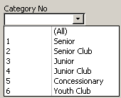
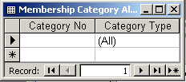
For a second example, consider a parameter on a form to allow the user to select all categories or a single category. One way of doing this would be by having a combo box where the user can select the required choice:
Create a new table, with two text fields, and just one row.
(The Category No field is left as null).

The following SQL will produce the result shown by the combo box:

SELECT [Category No], [Category Type]
FROM [Membership Category]
UNION
SELECT [Category No], [Category Type]
FROM [Membership Category All];

If the combo box on the form has the name cboCategoryNo and the form is called union – example 2 then the following SQL will select the required records:

SELECT *
FROM [Membership Category]
WHERE [Category No] LIKE forms![union - example 2]!cboCategoryNo & "*";

This SQL also illustrates the following:
- Use of * on SELECT clause to select all columns
- Use of * at the end of the WHERE clause to act as a wildcard.
  - Null & * will pick up all the categories (as Null & * is the same as just *)
  - 1 & * will pick up just category 1, etc. (It will also pick up 10-19, but there are only 6 categories, so far, in this scenario).
- Using the forms collection in a WHERE clause.

The following rules hold for the use of the UNION operator.
- SELECT statements must be specified with the same number of columns with the same datatypes in corresponding columns; i.e. the dynasets must match each other. (But example 2 above contradicts this! Perhaps Access is less fussy than some other RDBMSs).
- COLUMNS that will be combined in the results table can be from different domains; i.e. different tables. (Some other RDBMSs may require the same table/domain only).
- Only the last SELECT statement can contain an ORDER BY clause. SQL orders the end result using this.
- SELECT cannot use DISTINCT as UNION removes duplicate rows automatically.
This final point can cause problems; because it removes duplicate records, records can be removed which are not really duplicates. In the first example above had category 4 been included in the SELECT statement the results would have had two records with Looker, which would have been correct, however this would have been displayed as one record, which may not always be what is wanted. If you want to prevent this, then add extra fields (as described in Distinct) to make duplicate records more obvious to the DBMS

EXERCISE C
1. Repeat the first UNION query using Category No = 4 as a condition.
2. Write the above query (Exercise C.1) as a normal query (using OR) and compare the result with that from Exercise C.1.
3. Add additional field(s) to Exercise C.1 to ensure only true duplicates are removed.
Check your answers.
AGGREGATION FUNCTIONS IN SQL QUERIES
SQL statements can include various arithmetical functions. These are often referred to as aggregation functions. The traditional list of functions is:
MAX - maximum of a set of values
MIN - minimum of a set of values
AVG - average of a set of values
COUNT - total number of rows
SUM - sum of a set of values

MAX
SELECT Max([Membership Fee])
FROM [Membership Category];
Using the Chelmer Leisure data values this will give you the maximum membership fee, £30.
The results are shown in a table where Access has given the column a heading of its own. This is not very meaningful, so use an AS clause to give the heading a name of your choice.
SELECT Max([Membership Fee]) AS [Max Fee]
FROM [Membership Category];

COUNT
SELECT COUNT (*) AS [Total Members]
FROM Membership;
This will give you the total number of rows (members) in the membership table. The wildcard (*) implies all attributes in a row. This can be used because we are interested in the number of rows, which is independent of the number of columns required, i.e. 20 members with the data in McBride.
An identical count would occur from the statement below unless there are any NULL values in MembershipNo or DISTINCT is used when duplicates occur.
SELECT COUNT([Membership No]) AS [Total Members]
FROM Membership;

EXERCISE D
1. Write a query to count the number of classes held at the Leisure Centre in a week.
2. Write a query to calculate the average no of items in Stock.

You may find that it helps to write a SELECT query first, and then add the aggregate function afterwards to do the totalling on the rows.

Print out the query and the output produced for each query and check your answers.

GROUP BY & HAVING
Sometimes you want to examine rows that have certain elements in common as a group, rather than individual rows. For example, suppose you want to know the number of classes taken by a class tutor.
To perform this sub-setting of rows into groups before any statistical analysis is performed, a GROUP BY clause is added to the SELECT statement (after the WHERE clause, but before the ORDER BY clause, if these exist).
For example, to answer the above query, you can add the arithmetic function to the SELECT statement in the following way and use a GROUP BY to collect together the classes by each tutor.
SELECT [Class Tutor], COUNT([Class Tutor]) AS [Total Classes]
FROM Classes
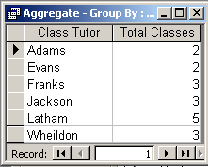
GROUP BY [Class Tutor];
The GROUP BY is performed first, and the COUNT([Class Tutor]) therefore refers to each group rather than the entire table. The GROUP BY clause will count up the rows for each group.
Note that Class Tutor is also selected so that the class tutor’s name is included in the results. Try it without and you will see that the result is meaningless.

HAVING
Supposing we want the number of classes a tutor has only when it is more than 3, to find those tutors who have more than three classes. We can't introduce this condition as part of a WHERE clause as it is a condition based on the groups of rows rather than on the entire table.
To provide conditions on groups of rows, we introduce another clause to the SELECT statement; the HAVING clause. This follows immediately after the GROUP BY clause, and cannot exist without it.
Thus, to modify the previous example as outlined above, we provide the following SQL statement:
SELECT [Class Tutor], COUNT([Class Tutor]) AS [Total Classes]
FROM Classes
GROUP BY [Class Tutor]
HAVING COUNT([Class Tutor]) > 3; e.g. Latham with 5

Note that the HAVING clause cannot refer to the Total Classes column by name, as the SQL does not appear to recognise it.

EXERCISE E

1. Write a query to count the number of members in each membership category.

Print out the query and the output produced for each query and check your answers.

JOINING TABLES
Sometimes, in order to satisfy a query, data from more than one table needs to be output or manipulated as part of satisfying that query.
For instance, it may be required to find all the names and contact details of all tutors who have a class. To find the information requested, the following SQL statement would work:
SELECT DISTINCT Tutor.Initials, Tutor.Lastname, Tutor.[Telephone No]
FROM Tutor, Classes
WHERE Tutor.Lastname = Classes.[Class Tutor];
Study this query.
The fields now have their full name shown by the notation tablename.fieldname. This is not always necessary where field names are unique, but it can sometimes be easier to put the full name of all fields when you have more than one table rather than working it out each time.
The data fields we wish to appear in our output are all contained in the tutor table but we don’t know whether we want all or some of the tutors’ details so we need to look at the classes table, see who has classes and then get their details from the tutor table.
If we look at the data in our tables we can do this manually quite easily, it is probably quicker than writing the query, however in a larger database there could be hundreds or thousands of rows in the table so it would be quicker (and more accurate) to write and run the query.
Thinking about how we do a task like this manually gives us some clues as to how the DBMS does it.
We are now using two tables, the Tutor table and the Classes table. We need to find who teaches each class and for each tutor we find in the class table we need to find the tutor’s details from the tutor table.
The tutor’s name is held in the tutor table as the primary key however the tutor’s last name is also held in the Classes table. It is a foreign key in the Classes table. The purpose of foreign keys is to allow the user to join the tables, through the WHERE clause. In this case if a name in the classes table is found in the tutor table we know it is the same person. We post primary keys into other tables as foreign keys to allow us to remove redundancy without losing any information
When we design databases we post the primary key to other tables as a foreign key which show us that there is a link and we can be sure if the foreign key and primary key have the same value they are referring to the same data item. When we post we keep the same data field name so it is easy to identify the foreign key. In this database this has not happened, the tutor’s last name has a different name in both tables. I know they are referring to the same person in this case but it is not wise to assume this normally, therefore to prevent problems it is good practice to keep the same name for the same thing regardless of how many tables it appears in as a foreign key. If you post identifiers (primary keys), this will not be a problem.
A temporary table is created with all the rows of Classes (18 rows) multiplied by all the rows of Tutor (7 rows); this table is thus a CARTESIAN PRODUCT of the two tables, and has 126 rows. Then the rows where the WHERE condition is true are selected from this large table and this is the result of the query. (Note: This is an internal temporary table used by the DBMS, the user will never see it).
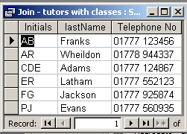
But a tutor can have more than one class (see GROUP BY and HAVING earlier in this guide), so the resultant query would have duplicate rows. DISTINCT has been added to the SQL to remove duplicates.
The final result of the query would be as shown here:
There are 7 tutors in the database, but only 6 listed by the query; Mrs R Jones does not have any classes so is not listed here.

Whenever tables are joined, unless all possible combinations of rows are required (i.e. a Cartesian product - not normally recommended or required, though can very occasionally be useful), the join conditions have to be specified in the WHERE clause.
Table1.PrimaryKey=Table2.ForeignKey
You can join as many tables as you want, but they must be linked as in the ER Model. When you create Relationships in MS Access, these are used by the Query Design Window to create the join conditions for the generated SQL. The SQL generated by Access for the above query is:
SELECT DISTINCT Tutor.Initials, Tutor.Lastname, Tutor.[Telephone No]
FROM Tutor INNER JOIN Classes ON Tutor.Lastname = Classes.[Class Tutor];

Note how Access has written the join. A WHERE clause is not used, but Access uses an INNER JOIN clause instead; this is not standard SQL.

When writing this type of query it is best to approach it in a structured way:
- Identify all the fields you require in the result and which tables they are located in. This becomes the SELECT clause
(remember to give the fields their full name: tablename.fieldname)
- The FROM clause will include all the tables you are using; you may add to it later.
- Make up the joins in the WHERE clause. This should be quite straightforward because joins are made using the Foreign keys and the Primary keys of the tables you know you need. Refer to your original database design. Is there a relationship between the tables you need? If not is there a table that links them, if so add it to your list of tables required. For each pair of tables there should be an expression of this form: Table1.PrimaryKey=Table2.ForeignKey (primary key from Table1). Join the join conditions with AND.
- Add any (other) conditions to the WHERE clause.
- Add any ORDER BY etc clauses.
Example.
The Leisure Centre has had a water leak today (13/5/96) and will therefore be closed. I will need to contact all the class tutors who have classes today; I will need their names and telephone numbers.
In our example database it is relatively easy to look through the data and find the information. However in large commercial databases there may be many hundreds or thousands of records meeting the criteria so it would not be practical (or accurate) to do it manually.
Following the five point plan:
Step 1. Identify the fields and the tables that they are in.
We need the Tutor’s Name and Telephone Number from the Tutor file
Therefore our first statement should be:
SELECT Tutor.Lastname, Tutor.[Telephone No]

Step 2. Tables Required
Tutor (From step 1)
We need to know what classes there are today and who the tutors are, so include the Bookings table.
The FROM Clause should now look like this:
FROM Bookings, Tutor (The order is unimportant)
The query so far
SELECT Tutor.Lastname, Tutor.[Telephone No]
FROM Bookings, Tutor

Step 3. By looking at The E:R model ( appendix 2)
There is no relationship between Booking and Tutor so we need to include another table to complete the joining process. By looking at the E:R diagram we can see that there is a relationship between Bookings and Classes and between Classes and Tutor, i.e. the Classes table links the two other tables. We therefore need to link the tables in the WHERE clause:
First Classes and Booking: Bookings.[Class No] = Classes.[Class No]
Then Classes and Tutor: Classes.[Class Tutor] =Tutor.Lastname
These need to be connected using AND
The WHERE clause now looks like this:
WHERE Bookings.[Class No] = Classes.[Class No] AND Classes.[Class Tutor] = Tutor.Lastname

Add the Classes table to the FROM clause

The query now looks like this
SELECT Tutor.Lastname, Tutor.[Telephone No]
FROM Bookings, Tutor, Classes ( Don’t forget to add classes)
WHERE Bookings.[Class No] = Classes.[Class No]
AND Classes.[Class Tutor] = Tutor.Lastname

Step 4 Add any selection conditions to the WHERE clause
We only want today’s bookings, so we are looking for bookings with a date of 13/5/96
Bookings.Date=#13/5/96#
Add this to the WHERE clause
The query now looks like this
SELECT Tutor.Lastname, Tutor.[Telephone No]
FROM Bookings, Tutor, Classes
WHERE Bookings.[Class No] = Classes.[Class No]
AND Classes.[Class Tutor] = Tutor.Lastname
AND Bookings.Date=#13/5/96#

Step 5 Add any ordering (none in this case).
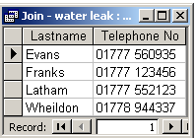
Add the semi colon and that is it.

The result of running the query should be:
EXERCISE F

1. Write a query to display the membership fee for each member, with their names and the date the fee is due (i.e. date of renewal) in date order.
2. Write a query to display all qualifications of tutors who teach Weight Training.
3. Write a query to find the name and telephone Number of all members who have bookings.

Print out the query and the output produced for each query and check the answers.

SUB QUERIES

Sub queries are an alternative way of doing complex queries. They work by running a query on the result of a query. Writing them requires care, as the order in which the queries are carried out is important.

If you are interested in reading about these types of queries, information can be found on Nigel Robert’s website as part of his ON-line SQL tutor at http://www.cse.dmu.ac.uk/~ndr

There is an example of a sub query on page 12 of this SQL guide (NOT IN, example 4).
A further example is FAQ 13 on the Frequently Asked Questions page of http://www.cse.dmu.ac.uk/~mcspence/Access.htm

UPDATE
Updating rows, or values in rows, is achieved via the UPDATE SQL statement.
UPDATE table name
SET [column_name = [expression | NULL]],…
{WHERE condition};
Notation:
- Square brackets [ ] mean that the item must be present.
  - The SET clause must have a column name.
- A series of dots … means that the item can be repeated.
  - The SET clause can have more than one column name, comma-separated.
- A vertical line | means that one of the options presented must be chosen.
  - SET column_name = 3 and SET column_name = Null are both valid clauses (given appropriate datatypes for the column).
- Curly brackets { } mean that the item is optional.
  - The WHERE clause is optional.
  - WHERE clauses can be as complicated as any in a SELECT statement (e.g. using subqueries, unions etc.).

You may like to make a copy of your table before running each query, as UPDATE will change the data in the table.

e.g. change the membership fee for concessionary users (category 5) to £20:
1. UPDATE [Membership Category]
SET [Membership Fee] = 20
WHERE [Category No] = 5;

Run this query and check that the correct record has been updated.

e.g. increase the membership fees by £5 for everyone:
2. UPDATE [Membership Category]
SET [Membership Fee] = [Membership Fee] + 5;

The first reference to membership fee is to the new value, and second to the old value (just like an assignment statement in many programming languages – the result goes on the left-hand side of the equation).

More than one column can be referred to in the SET part of the UPDATE statement:
3. UPDATE Membership
SET Street = "124 Livery Lane",
[Post Code] = "ST10 5TH"
WHERE [Membership No]=12;

Note the comma between each item on the SET clause.

DELETE
The DELETE SQL statement allows you to delete rows from tables.
DELETE
FROM table_name
{WHERE condition};

The DELETE statement deletes entire rows, not data in selected fields. Column names are only used on the optional WHERE clause.

e.g. deleting all Bookings rows can be achieved as follows
1. DELETE
FROM Bookings;

Before you try this query, make a copy of your Bookings table, so that you can re-instate the data afterwards!

e.g. deleting only those associated with a particular member:
2. DELETE
FROM Bookings
WHERE [Membership No] = 2;

Try this query (re-enter the data when you have done it, or copy/paste/rename from your backup copy of the table)

Again the WHERE clause can be as complicated as in a SELECT statement, if required.

EXERCISE G
1. Write a query to change The Monday Ladies’ Aerobics class to Aerobics and Mixed.
2. Write a query to delete all classes with the class tutor Jackson.

Print out the query and the table before and after you have run the query to check your answers.

INSERT

The INSERT SQL statement allows you to insert rows into tables.

INSERT INTO table_name {column1,…}
VALUES (expression1, …)

There is no WHERE clause here, as we are just inserting data, not selecting data according to specific criteria.

Specifying the column names is optional, but if they are missed off the VALUES must be in the same order as the table fields.

e.g. Add a new Category to the Membership Category table:

1. INSERT INTO [Membership Category]
VALUES (7, "Student", 12);

The column names are not specified here, so the VALUES are in the same order as in the table.
- The Category No is a numeric field so is shown as a simple number.
- The Category Type is a string (text) field, so needs quotation marks around it.
- The Membership Fee is also a number field (currency).

e.g. Add a new Member Booking to the Bookings table.

2. INSERT INTO Bookings ( [Room/Hall/Court], [Member/Class], [Membership No], [Date], [Time] )
VALUES ("Court 1", Yes, 3, #4/15/2004#, #12/30/1899 10:0:0#);

Here some (but not all) column names are specified, as not all of the columns will have data.
- One of the unspecified columns is Booking No which is an AutoNumber field; Access will allocate the next available value automatically.
- Member/Class is a Yes/No field.
- Date and Time are Access reserved words, so need to be written with square brackets around them to identify them as fields of the Bookings table.
- The columns that are not listed on the INSERT clause will be left Null, or with any default value that has been specified.

EXERCISE H
1. Write a query to add a new tutor to the Tutor table.
2. Write a query to add a new class to the Classes table.

Look at the table after running the query and check that the new row has been added correctly.

Appendix 1: Data for the Chelmer Leisure Database

Membership Table.
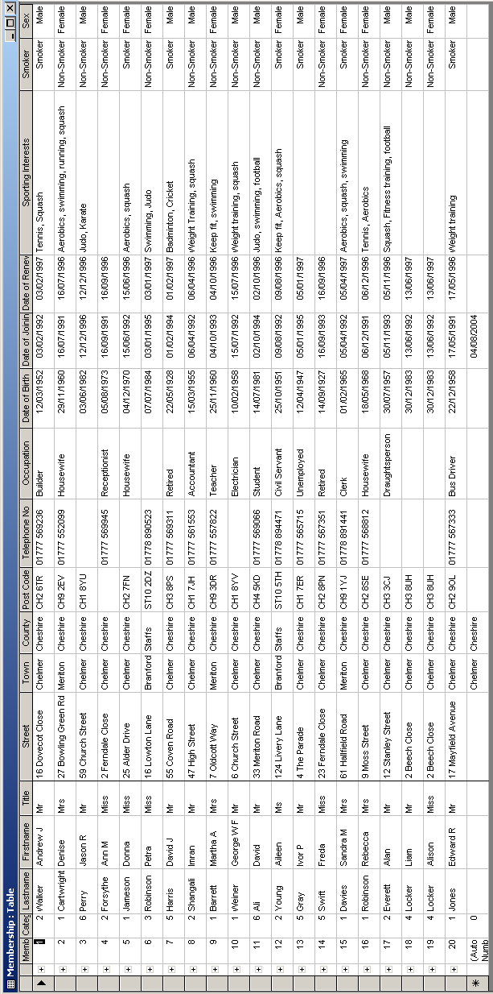

Bookings Table
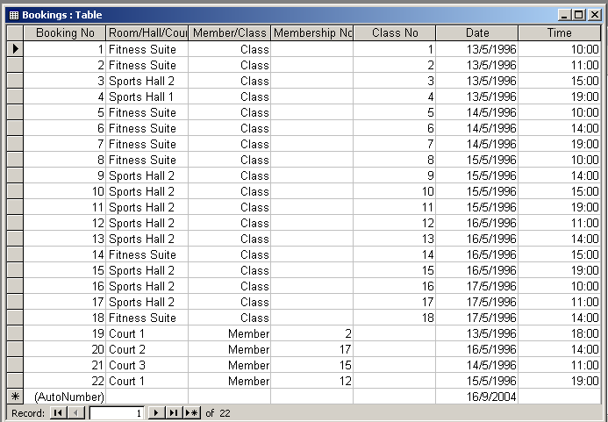

Membership Category Table

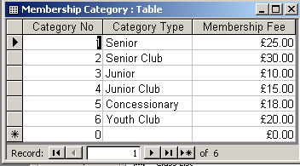

Stock Level Table
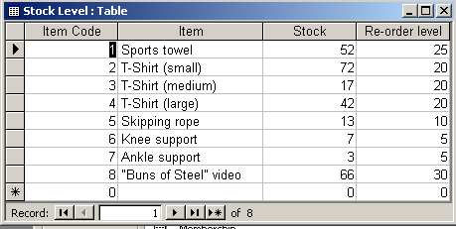

Classes Table
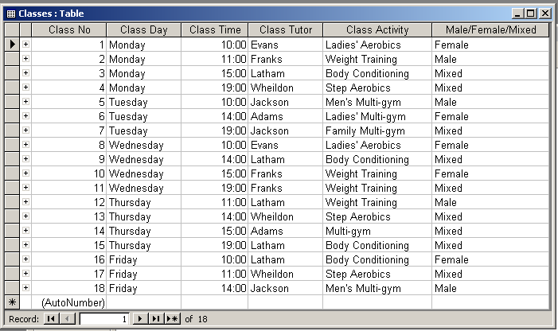

Class List Table
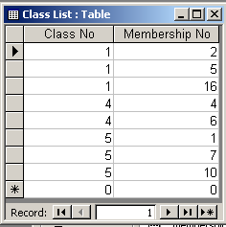

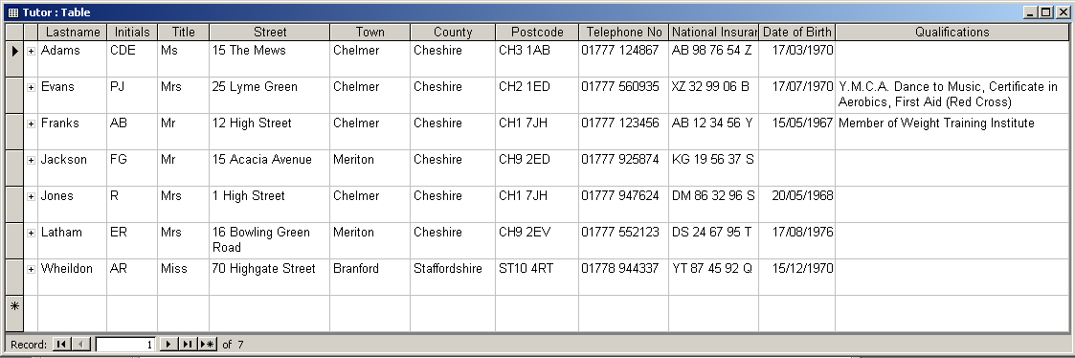
Tutor Table

Appendix 2: Relationships Window - Chelmer Leisure Centre

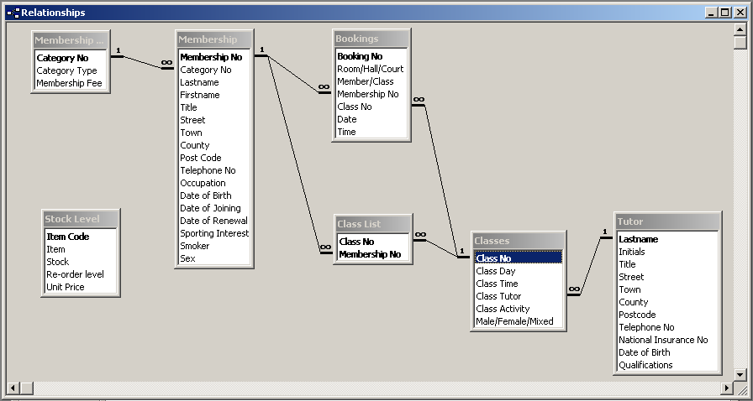

Appendix 3 SQL PROBLEMS

Finding the SQL editor
There are various ways. If the Design icon is not shown (or SQL within that icons menu) View is reliable, click on VIEW on the main menu and select SQL VIEW.

Errors in SQL Statements
There are three main types of Error

- Does not save:- error message displayed

If you cannot save the query when you have written it, it usually means there is a syntax error (you are not following the rules of the language)

Click on OK to remove the message box. The editor will usually take you to the place where it first noticed the error.

Check the punctuation (have you forgotten or got an extra comma, semicolon or forgot to leave a space between words)
Are all the mandatory words present (E.g. SELECT FROM), and in the right order
Have you remembered the semi colon on the end, are the fields and table names correct (have you spelt them wrong or given them a name different to the one in the table).
If there is more than one table have you included the correct name for the fields (table. field).
Check your brackets if there are any.

This is not an exhaustive list

- Access asks for input data when opening a query

When you try and open the query, access displays a data entry box asking for a value for a field
This means that the field in the query not the same as any fields in the table. In other words a spelling mistake, check the name of the field in the table (click Table Design) and edit your query so they are now the same.

- Incorrect data displayed

This is because the logic of your query is incorrect. The syntax is correct it just is not doing what you expected.
Check any logical and numeric operators (AND, OR , <, > etc) This is the usual source of these types of errors. If you can’t see what is wrong ask your tutor or a friend they can often see it immediately.
Check Brackets are grouping the correct clauses together.

