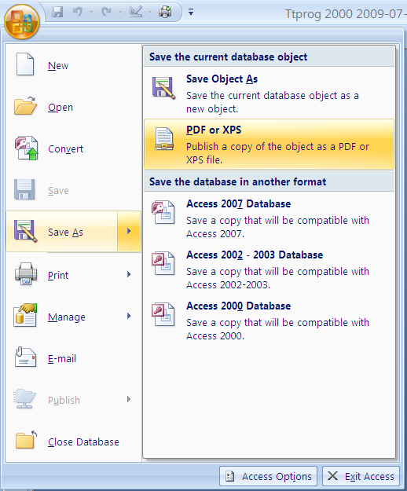
1. Look at the File→Save As options from the Office Button:

If yours looks like this then continue to point 2 below.

You may have an option that says something like: “see further options”. In which case see Get the Add-In at the end of this document, download the Add-In, close and reopen your database and check the options again – your menu should now show the option for ‘PDF or XPS’.

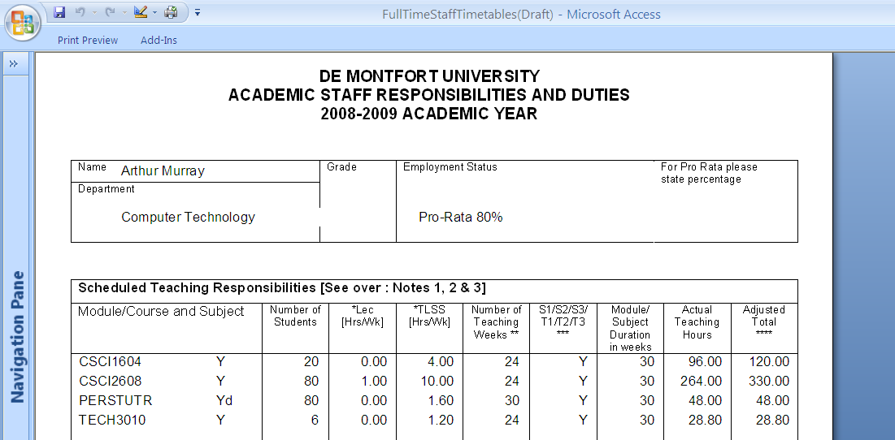

2. Open the required report in print preview then click on the report to select it. (If you don’t click on the report you may get information from some other item that Access thinks has been selected instead).

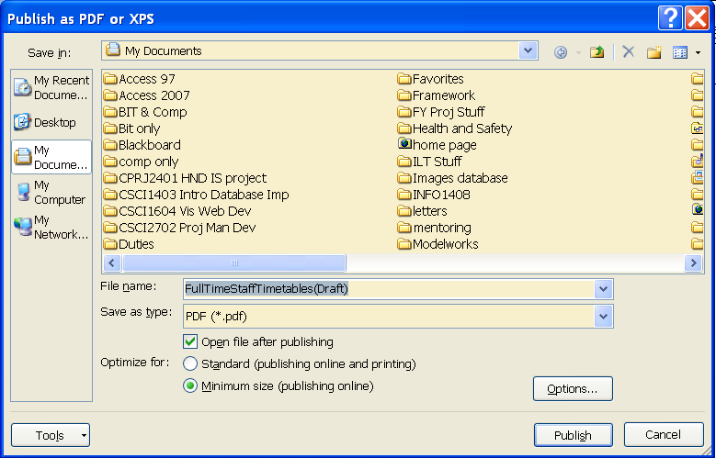

3. Choose File→Save As→PDF or XPS from the Office Button menu.
Check that the filename is that of your report (if you forgot to select the report you’ll probably have the name of something else here, as mentioned above).
Change the filename if wanted.
Set the relevant directory folder and options (and you can select specific pages if wanted), click on OK and that’s it.
The PDF document should now show the report page(s) with formatting intact.

Get the Add-In.
Click on the option of this name in the Office Button menu and you should be directed to the web page at http://www.microsoft.com/downloads/details.aspx?familyid=4D951911-3E7E-4AE6-B059-A2E79ED87041&displaylang=en where you can download SaveAsPDF and XPF.exe
This will only take a few minutes. Then close and reopen your database.

