The screen prints shown in McBride Unit 1 do not apply to Access 2003. Follow the instructions below to open Access and create a new database:

Stage 1 – select Start menu and find MS Office / MS Access

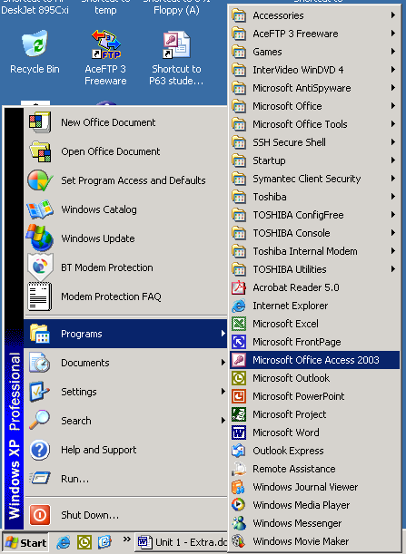

MS Access may be on the list under MS Office.

Or it may be available (as here) on the main list.

Start menu is available at bottom left of screen.

Once you have located MS Access, simply click on the link to open.

Step 2 – the Access Window.

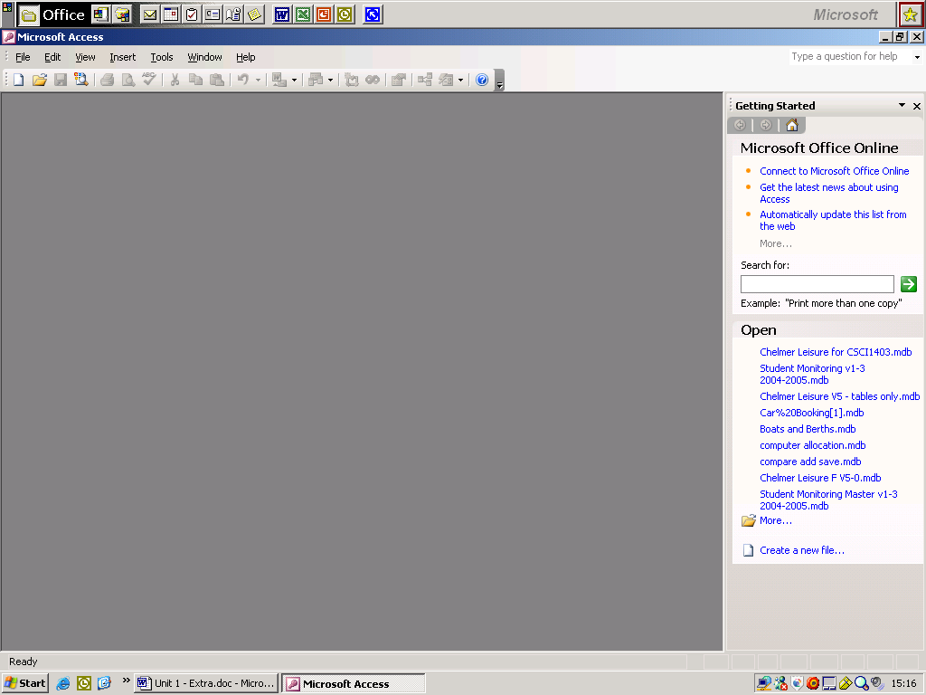
Access 2003 opens with a window like this. This is different from the screenprint shown in Fig 1.1 on page 1 of McBride.

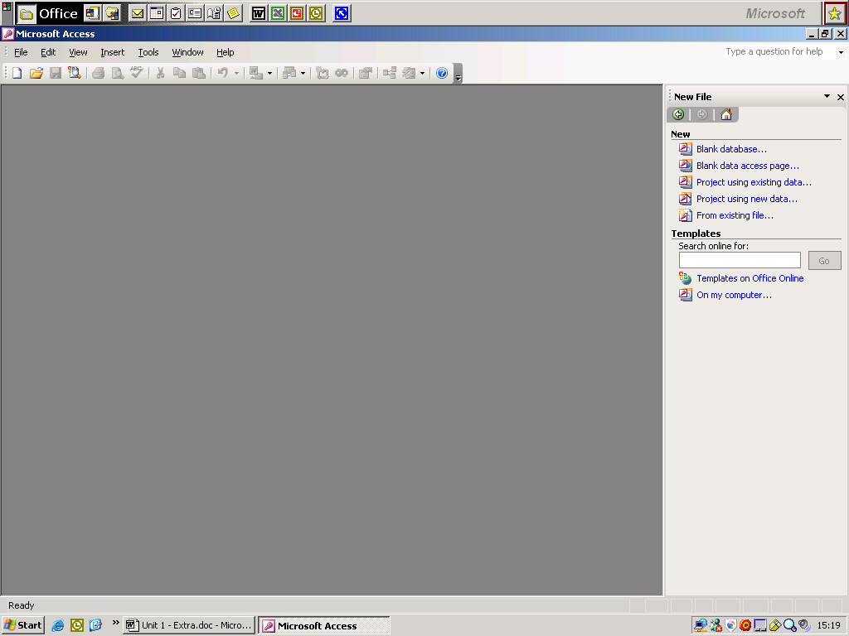
Click on one of these to open an existing database.
Click on one of these to open a new database.
Then click here to open the required type of new database.
For this module all you need is to choose ‘Blank database’.

You should then have a window similar to McBride Fig 1.2 on page 2, and can save/reopen the database as shown on pages 8 and 9 of McBride.

