Booking Systems
Booking systems are often done very badly in student projects. The main reason for this is that they are quite hard to write well and there are often really important use cases missing from the design.
Have a think about the following booking screen and consider what the problems might be.
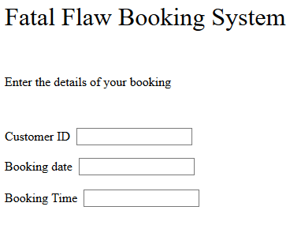
The first problem with the design is that we are asking the user to type their customer ID. In some cases this is fine but what if they cannot remember it? If your system requires a user to log in then the system already knows this ID so why not complete it automatically and show the name of the person to the customer.
This is especially important when thinking about the backend of the system. As a member of staff it is unlikely that I will have memorised all of the customers on the system so it is much better to show their name. Fred Smith will likely mean a lot more to me that customer 183735!
But there is another problem that is a bit more subtle.
Here is the question.
If somebody wants to book an appointment with me and picks a date and time in the week that is OK for them, how do they know I am available?
If my availability on Monday is as follows...
 | Monday
9:00 | Booked
10:00 | Booked
11:00 | Booked
12:00 | Booked
13:00 | Lunch
14:00
15:00 | Booked
16:00 | Booked

This process becomes a guessing game with a 1 in 8 chance of getting it right or putting it another way 7 out of 8 chances will be wrong.
If a user is constantly greeted with the message “sorry not available”, or even worse you allow double or triple bookings, then this will not produce a terribly effective system!
There are two use cases that are often missed off booking systems, these are...
- Check Availability
- Create Availability
Check Availability allows you as the person booking the system to view the current availability of the person you wish to see and compare with your own availability.
Create Availability allows the person at the back end of the system to create free slots on the system for people to possibly book themselves into.
A possible set of use cases might look like this...
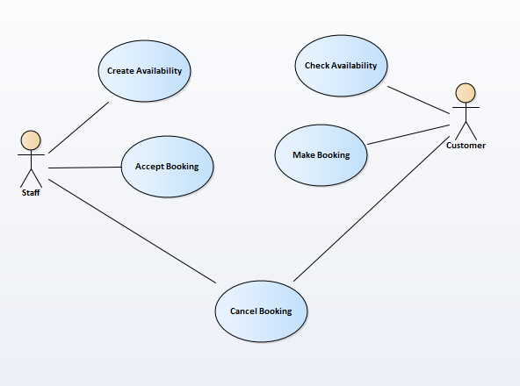
This however is only one example as there are a range of different booking systems that may be variations on the above theme.
We shall look at a couple of demo systems to give you some idea of how they might work. I will not be able to cover every different variation but there should be enough here to get you started.

Example 1 Daily Appointments
This is the sort of booking system where there are timed slots during the day which are either free or not e.g.
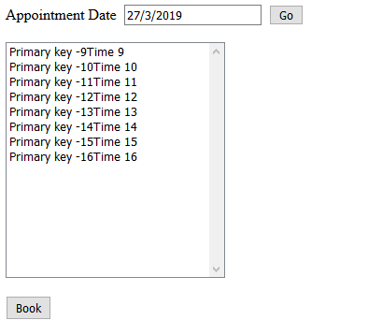
Could be used for GP appointments or car repairs.
The interface is intentionally a bit rubbish to show what is going on.
Notice how available slots are indicated as minus times e.g. -9.
The minus sign may be picked up by the system to identify it as a free slot.
Clicking on a free slot and pressing Book takes you to the second screen.
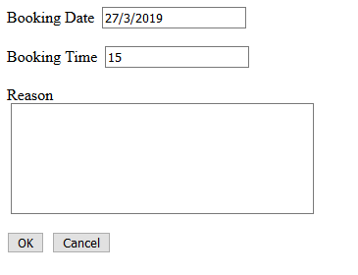
Notice how the date and time are completed automatically since we already know these values from the previous screen there is no point making the user enter them a second time.
In this example we are using the query string to pas the data between pages...
http://localhost:50577/MakeBooking.aspx?BookingDate=27/3/2019&BookingTime=-15
It isn’t secure but it allows us to easily see the inner workings of the system. In the final system it would be better to use the session object.
Entering a suitable reason adds the record to the database and takes you back to the main screen.
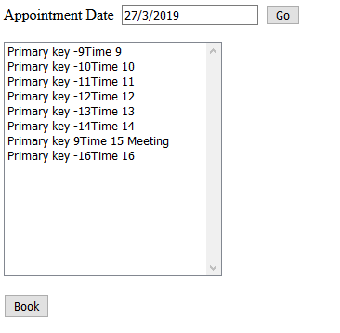
Notice how the primary key is now recorded as the primary key of the record in the underlying table. We cannot edit in this version but it would be fairly easy now to add edit functionality.

Here is the Problem

In this version of the system the Create Availability use case is dictated by the number of hours in a day. There is no point the staff doing this manually it needs to be done automatically by the system.
We “could” add a ton of records to the table, stating free hourly slots but that would be very inefficient.
Look at the table as it stands with one booking...
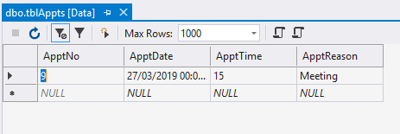
We only have one booking so it is only right that there should be only one record in the table.
How does this work?
The first step is to get a list of the records matching the data we are interested in.
This function in clsApptCollection does this...
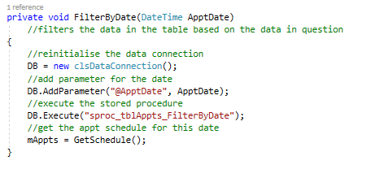
The data connection DB in this example will only contain one record...
The function GetSchedule is then called to create the list of available appointments for that date.
It starts at 9am and then scans the list in the data connection to see if there is a booking.
If there is a booking then it is added to the list for the day.
If there is no booking then it adds a blank booking with –time as the primary key.
Here is the main section of code...
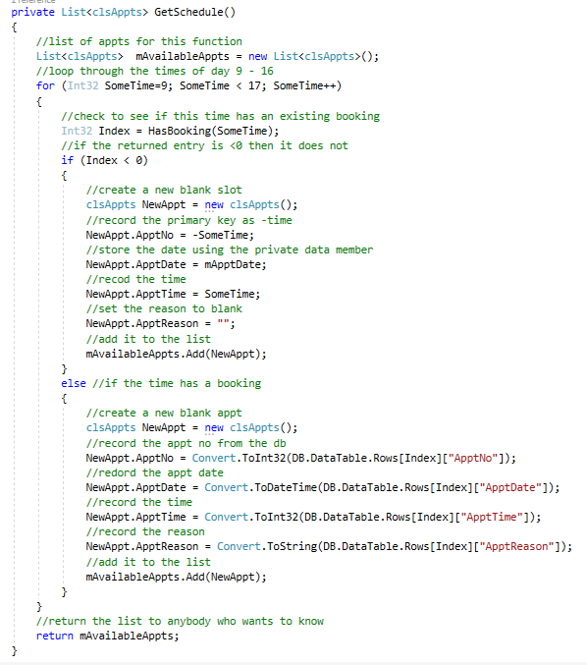
If staff are required to manually add available bookings then you would need to create some sort of admin screen allowing for this to happen.

Example 2 Availability between Dates
In this second example we are looking at a system where there is the option of entering four dates.
This is the type of situation that arises in the case of such systems as car hire and holiday bookings.
For example if you want to hire a car you will likely need it from a start date to an end date...
Your booking 10th ------ 12th
There may then be a number of cars available to hire but not all will be available during the time span you specify.
Car 1 Booked 1st ------ 9th
Car 2 Booked 11th ------ 14th
Based on the logic above which car is available?
The core of this second system is the following stored procedure
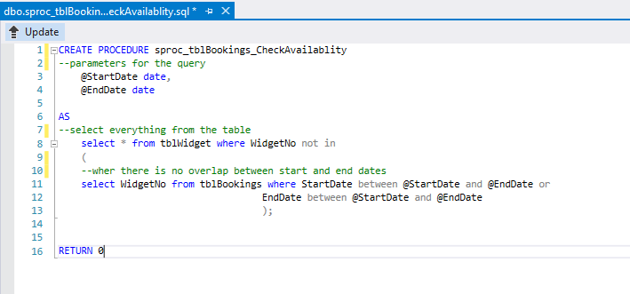
Notice the use of “not in”
The first thing the query does is produce a list of widgets that overlap with the specified dates...
select WidgetNo from tblBookings where StartDate between @StartDate and @EndDate
or
EndDate between @StartDate and @EndDate
That is booked items.
It then compares this with a list of all widgets and displays only those that are not in the first list...
select * from tblWidget where WidgetNo not in

Closing Remarks
There are lots of variations on booking systems so it is difficult to cover all of them here.
The trick is don’t forget the two use cases Check Availability and Create Availability.
As before the code in these examples isn’t perfect and doesn’t cover every eventuality but there is sample code for many of the more tricky features.
Again examine the code and understand how it works at each layer of the system.

