PROJECT x: EXTENDING EYE TRACKING MOODLE SYSTEM TO MOTIVATIONAL PERSONALISED LEARNING SYSTEM

# Project Outline

Students’ high level of motivation to learn is associated with their learning success. User motivation is a response to the interaction process and is fundamental for the success of the interaction process. Recognition of the role of identified motivational factors can contribute to an assessment of the interface and can be an indicator of how well design has addressed user needs. That’s why we need to recognise and use techniques to enhance user motivation in the interaction process, in order to attract and sustain the interest of the target audience. Specifically, students with various kinds of learning difficulties such as dyslexia can cause young people not to engage fully with the education system or drop out. Thanks to the advancement of assistive learning system and user modelling techniques for personalised learning, the different individual learning needs and preferences can be taken into account and met by personalising the learning environment based on user models.

One of our DMU students has already developed an eye tracking learning system with course materials based on Moodle learning platform. View a quick demonstration video here: http://xxxxxxxxxxx. The system can continually monitor learners’ eye movements when they are using the system along with the percentage of eye gaze time spent on text, images and out of the screen and monitor learner behaviour such as clicking history and navigation behaviour as well as record learning task performance including test score, learning completion time, etc.

However, the motivational factors that are essential to learning success are not included in the system yet. By incorporating motivational factors into student modelling in the system, personalisation can be further applied based on student motivation model. We already have a motivation model and the corresponding motivation questionnaire and the inference rules as well, and we will need the system to collect the user behaviour data combined with the motivation model and inference rules, to output the learning content based on the inferenced results. The initial personalisation of learning content will be performed based on the motivation questionnaire and the rules, and then the real-time user behaviour data will be recorded and used to update user’s motivation, according to the real-time motivation, adaptive feedback will be output to user to sustain and enhance their motivation. The basic system architecture and its working principles is shown here:

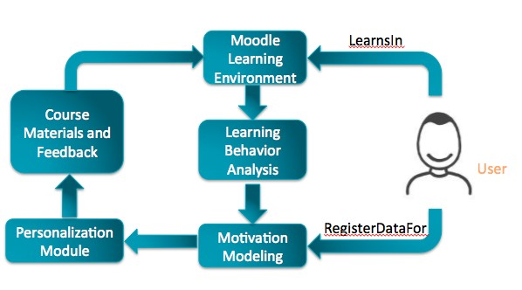

The motivation plays a role in the teaching process primarily in the quantity of course materials presented to the student. For example, high motivated students tend to learn faster and to accept learning content in bigger quantities, while low motivators must be presented with smaller knowledge chunks with appropriate feedback, trying to increase their motivation. Another interesting perspective on motivation includes the idea of positive feedback as a kind of retribution or praise with a series of studies showing the effects of feedback interventions as altering user's motivational state. Therefore, based on the data collection combined with the motivation model and inference rules, the output will be different quantities of course materials with feedback to user.

# Project Objectives

The objectives are to extend the current eye tracking Moodle system that involves:

* Identifying user’s motivation at the beginning and in real-time.
* Recording and storing user’s real-time data including eye movement and learning task performance (i.e., time spent on a page, time spent on a test, test score, etc.).
* Updating the motivational state with the aforementioned real-time data.
* Providing learning content (i.e., feedback and course quantity) for user based on the real-time motivational state.

# Prerequisite

Basic programming skills in C++/Java/Python.

Some experience of developing e-learning system will be beneficial.

Technical Requirements: YELLOW (Traffic light indicator)

# Expected Deliverables

A system prototype with documentations and dissertation report covering following aspects:

* Incorporating a motivation questionnaire (developed already) in the registration form.
* Recognising user attention by collecting eye-tracking data using given analysis method.
* Updating the motivational state with eye-tracking data and other recorded indicators such as browsing time using pre-defined rules.
* Allowing the motivation model and inference rules to be entered in the system
* Outputting the course content (with feedback and course quantity) based on the inference results.

# Supervisor – Prof Liming Chen/ Ruijie Wang

|  |  |
| --- | --- |
| Professor of Computer Science  GH 5.34 - The Gateway  De Montfort University  LE1 9BH  T: +44 (0) 116 207 8490  E: liming.chen@dmu.ac.uk | Ruijie Wang (PhD Student at CIIRG)  GH 6.19 - Gateway House  De Montfort University  LE1 9BH  E: p1523357x@my365.dmu.ac.uk |

**Ruijie will provide:**

1.The motivation model and questionnaire along with the pre-define weight of motivational factors in the motivation model/questionnaire; 2. Which user behaviour data serves as the indicators of which motivational factors to be collected; 3. Inference rules (input: motivation; output: Levels of course quantity; Feedback expressions and messages); 4. Levels of course quantities and Feedback expressions and messages.